**juRunning linux from Another machine**

-> Running linux machine from another OS

connect window machine to another window machine you can

user => Remote Desktop(RDP)

connect linux machine from window = Putty , SecureCRT

connect linux machine from linux = ssh

**Linux File System**

#### */bin*

*>> /bin* is the directory that contains *bin*aries, that is, some of the applications and programs you can run. You will find the *ls* program mentioned above in this directory, as well as other basic tools for making and removing files and directories, moving them around, and so on. There are more *bin* directories in other parts of the file system tree, but we’ll be talking about those in a minute.

#### */boot*

The */boot* directory contains files required for starting your system. Do I have to say this? Okay, I’ll say it: **DO NOT TOUCH!**. If you mess up one of the files in here, you may not be able to run your Linux and it is a pain to repair. On the other hand, don’t worry too much about destroying your system by accident: you have to have superuser privileges to do that.

#### */dev*

*/dev* contains *dev*ice files. Many of these are generated at boot time or even on the fly. For example, if you plug in a new webcam or a USB pendrive into your machine, a new device entry will automatically pop up here.

#### */etc*

*/etc* is the directory where names start to get confusing. */etc* gets its name from the earliest Unixes and it was literally “et cetera” because it was the dumping ground for system files administrators were not sure where else to put.

Nowadays, it would be more appropriate to say that *etc* stands for “Everything to configure,” as it contains most, if not all system-wide configuration files. For example, the files that contain the name of your system, the users and their passwords, the names of machines on your network and when and where the partitions on your hard disks should be mounted are all in here. Again, if you are new to Linux, it may be best if you don’t touch too much here until you have a better understanding of how things work.

#### */home*

*/home* is where you will find your users’ personal directories. In my case, under */home* there are two directories: */home/paul*, which contains all my stuff; and */home/guest*, in case anybody needs to borrow my computer.

#### */lib*

*/lib* is where *lib*raries live. Libraries are files containing code that your applications can use. They contain snippets of code that applications use to draw windows on your desktop, control peripherals, or send files to your hard disk.

There are more *lib* directories scattered around the file system, but this one, the one hanging directly off of */* is special in that, among other things, it contains the all-important kernel modules. The kernel modules are drivers that make things like your video card, sound card, WiFi, printer, and so on, work.

#### */media*

The */media* directory is where external storage will be automatically mounted when you plug it in and try to access it. As opposed to most of the other items on this list, */media* does not hail back to the 1970s, mainly because inserting and detecting storage (pendrives, USB hard disks, SD cards, external SSDs, etc) on the fly, while a computer is running, is a relatively new thing.

#### */mnt*

The */mnt* directory, however, is a bit of remnant from days gone by. This is where you would manually mount storage devices or partitions. It is not used very often nowadays.

#### */opt*

The */opt* directory is often where software you compile (that is, you build yourself from source code and do not install from your distribution repositories) sometimes lands. Applications will end up in the */opt/bin* directory and libraries in the */opt/lib* directory.

A slight digression: another place where applications and libraries end up in is */usr/local*, When software gets installed here, there will also be */usr/local/bin* and */usr/local/lib* directories. What determines which software goes where is how the developers have configured the files that control the compilation and installation process.

#### */proc*

*/proc*, like */dev* is a virtual directory. It contains information about your computer, such as information about your CPU and the kernel your Linux system is running. As with */dev*, the files and directories are generated when your computer starts, or on the fly, as your system is running and things change.

#### */root*

*/root* is the home directory of the superuser (also known as the “Administrator”) of the system. It is separate from the rest of the users’ home directories BECAUSE YOU ARE NOT MEANT TO TOUCH IT. Keep your own stuff in you own directories, people.

#### */run*

*/run* is another new directory. System processes use it to store temporary data for their own nefarious reasons. This is another one of those DO NOT TOUCH folders.

#### */sbin*

*/sbin* is similar to */bin*, but it contains applications that only the superuser (hence the initial *s*) will need. You can use these applications with the sudo command that temporarily concedes you superuser powers on many distributions. */sbin* typically contains tools that can install stuff, delete stuff and format stuff. As you can imagine, some of these instructions are lethal if you use them improperly, so handle with care.

#### */usr*

The */usr* directory was where users’ home directories were originally kept back in the early days of UNIX. However, now */home* is where users kept their stuff as we saw above. These days, */usr* contains a mish-mash of directories which in turn contain applications, libraries, documentation, wallpapers, icons and a long list of other stuff that need to be shared by applications and services.

You will also find *bin*, *sbin* and *lib* directories in */usr*. What is the difference with their root-hanging cousins? Not much nowadays. Originally, the */bin* directory (hanging off of root) would contain very basic commands, like ls, mv and rm; the kind of commands that would come pre-installed in all UNIX/Linux installations, the bare minimum to run and maintain a system. */usr/bin* on the other hand would contain stuff the users would install and run to use the system as a work station, things like word processors, web browsers, and other apps.

But many modern Linux distributions just put everything into */usr/bin* and have */bin* point to */usr/bin* just in case erasing it completely would break something. So, while Debian, Ubuntu and Mint still keep */bin* and */usr/bin* (and */sbin* and */usr/sbin*) separate; others, like Arch and its derivatives just have one “real” directory for binaries, */usr/bin*, and the rest or *\*bin*s are “fake” directories that point to */usr/bin*.

#### */srv*

The */srv* directory contains data for servers. If you are running a web server from your Linux box, your HTML files for your sites would go into */srv/http* (or */srv/www*). If you were running an FTP server, your files would go into */srv/ftp*.

#### */sys*

*/sys* is another virtual directory like */proc* and */dev* and also contains information from devices connected to your computer.

In some cases you can also manipulate those devices. I can, for example, change the brightness of the screen of my laptop by modifying the value stored in the */sys/devices/pci0000:00/0000:00:02.0/drm/card1/card1-eDP-1/intel_backlight/brightness* file (on your machine you will probably have a different file). But to do that you have to become superuser. The reason for that is, as with so many other virtual directories, messing with the contents and files in */sys* can be dangerous and you can trash your system. DO NOT TOUCH until you are sure you know what you are doing.

#### */tmp*

*/tmp* contains temporary files, usually placed there by applications that you are running. The files and directories often (not always) contain data that an application doesn’t need right now, but may need later on.

You can also use */tmp* to store your own temporary files — */tmp* is one of the few directories hanging off / that you can actually interact with without becoming superuser.

#### */var*

*/var* was originally given its name because its contents was deemed *variable*, in that it changed frequently. Today it is a bit of a misnomer because there are many other directories that also contain data that changes frequently, especially the virtual directories we saw above.

Be that as it may, */var* contains things like logs in the */var/log* subdirectories. Logs are files that register events that happen on the system. If something fails in the kernel, it will be logged in a file in */var/log*; if someone tries to break into your computer from outside, your firewall will also log the attempt here. It also contains *spools* for tasks. These “tasks” can be the jobs you send to a shared printer when you have to wait because another user is printing a long document, or mail that is waiting to be delivered to users on the system.

Your system may have some more directories we haven’t mentioned above. In the screenshot, for example, there is a */snap* directory. That’s because the shot was captured on an Ubuntu system. Ubuntu has recently incorporated [snap](https://www.ubuntu.com/desktop/snappy) packages as a way of distributing software. The */snap* directory contains all the files and the software installed from snaps.

To explore the filesystem yourself, use the cd command:

cd

will take you to the directory of your choice (*cd* stands for *change directory*.

If you get confused,

pwd

will always tell you where you (*pwd* stands for *print working directory*). Also,

cd

with no options or parameters, will take you back to your own home directory, where things are safe and cosy.

Finally,

cd ..

will take you up one level, getting you one level closer to the */* root directory. If you are in */usr/share/wallpapers* and run cd .., you will move up to */usr/share*.

To see what a directory contains, use

ls

or simply

ls

to list the contents of the directory you are in right now.

ls -l to see long listing of files and folder

results

**drwxr-xr-x** 2 sandip sandip 4096 अप्रैल 29 22:07 Videos

**-rw-------** 1 sandip sandip 11291 फरवरी 25 11:33 .viminfo

drwxrwxr-x 3 sandip sandip 4096 दिसम्ब 9 16:41 .vscode

-rw-r--r-- 1 sandip sandip 173 नवम्बर 18 2019 .wget-hsts

drwxr-xr-x 16 sandip sandip 4096 मई 13 12:43 work

Anything that start with **d** is directory

Anything that start with **-** is file

**ls -a** also shows folders that start with (.)

**cd /** gets you to root directory

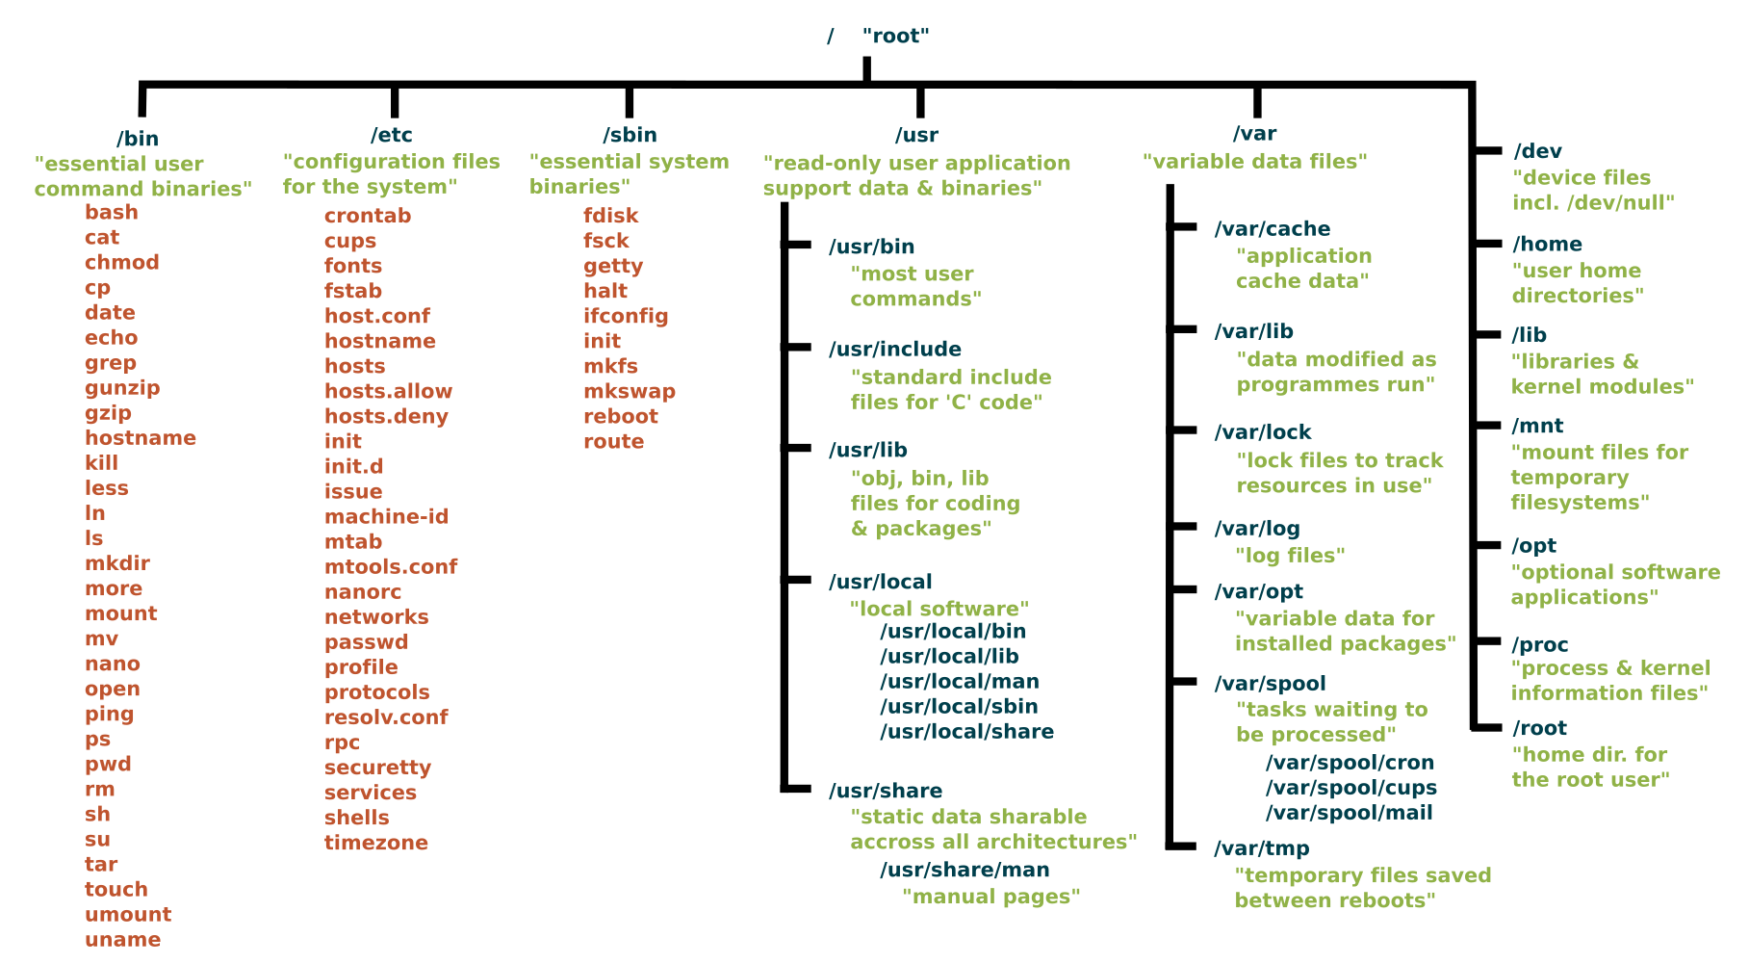

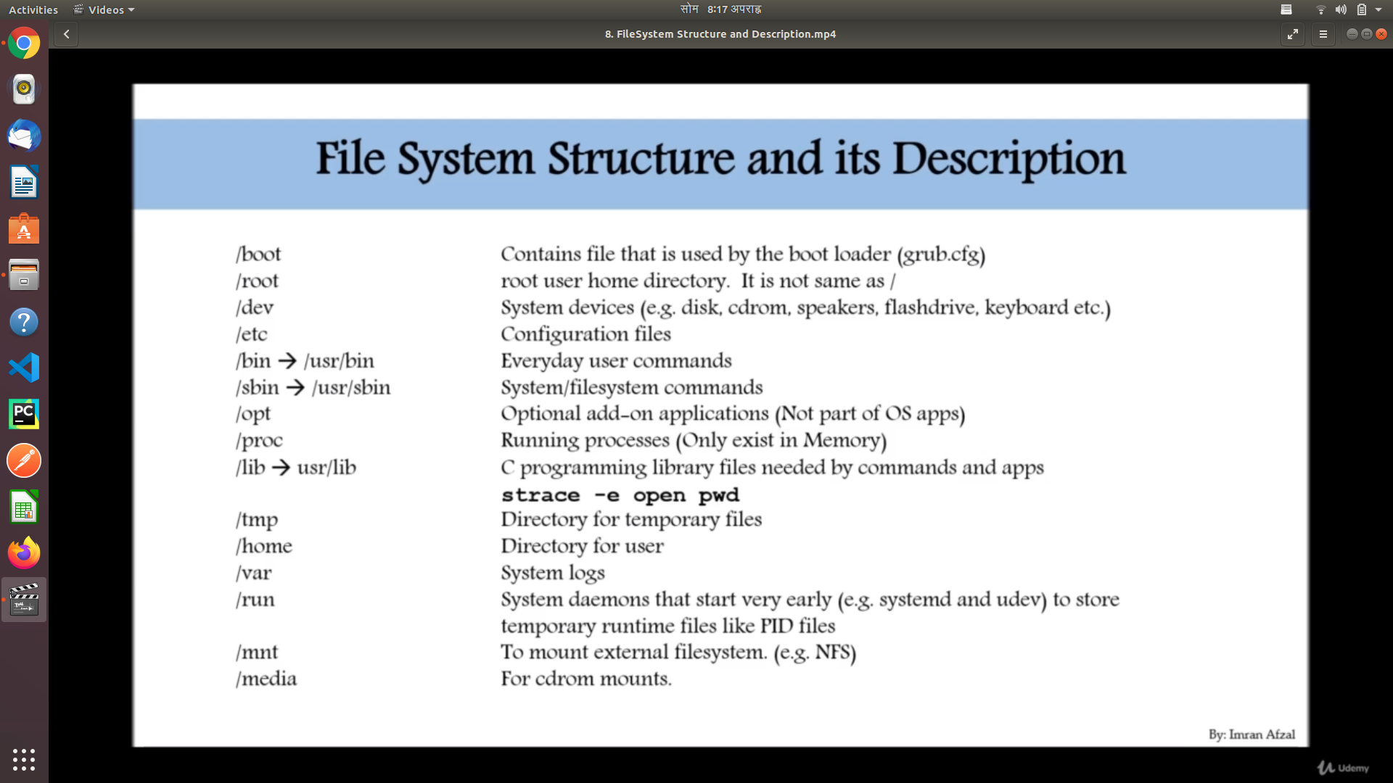

**File System Paths**

There are two paths to navigate to filesystem

* Absolute path
* Relative path
* An Absolute path always begins with “/ ” . This indicates that the path always starts at the root directory

Eg: cd /home/sandip/work

* A relative path does not begin with / . It identifies the location relative to your current position.

Eg cd home

Cd sandip

**Directory Listing Attribute**

When you do **ls -l**

**Type Link Owner Group Size Month Day Time Name**

**drwxr-xr-x** 2 sandip sandip 4096 अप्रैल 29 22:07 Videos

**-rw-------** 1 sandip sandip 11291 फरवरी 25 11:33 .viminfo

lrw-r--r-- 1 sandip sandip 173 नवम्बर 18 2019 .wget-hsts

Any file that starts with d (**drwxr-xr-x) is a directory**

**Any file that starts with l (**lrw-r--r--**) is a link**

**Any file that starts with nothing (-rw-------) is a regular file**

**Creating Files And Directories**

**(ls -ltr to list in reverse order of time)**

**Creating files**

1. **touch**

**Eg; touch <file_name>**

**Eg: touch <file_name1> <file_name2><file_name3> (creates multiple files at once)**

1. **cp**

**Eg; create a file name <sandip>**

**Create a new file using cp**

**cp sandip <new_filename> (It will copy the file sandip to file <new_filename> creating new file)**

1. **vi (vim command)**

**Eg: vi <file_name> (creates a file using vim text editor)**

**Creating Directories**

1. **mkdir**

**Eg: mkdir <filename>**

**Eg: mkdir <filename1> <filename2> <filename3> (create multiple directory at once)**

**Linux File Types**

| **File Symbol** | **Meaning** |
| --- | --- |
| - | Regular file |
| **d** | **Directory** |
| **l** | **Link** |
| **c** | **Special file or Device file(any device attach is created as file in linux)** |
| **s** | **socket** |
| **p** | **Named Pipe** |
| **b** | **Block device** |

**Finding Files And Directories**

Two main commands to find files and Directories:

* **find**

**Eg : find <find_from_directory> -name “<directory_name>”**

* **locate**

**Eg: locate <file_name>**

**find vs locate**

**⇒ locate uses a pre-built database which should be regularly updated, while find iterates** over a filesystem to locate files . Thus, locate is much faster then find but can be in accurate if the database is not updated

⇒ to update **locate** database run **updatedb**

**Change password:**

**⇒ passwd <userid>**

**sudo -i ⇒ to login as root**

**sudo -s ⇒ login as superuser**

**WildCards**

A wildcard is the character that can be used as a substitute for any of the characters in search.

* **\*** → represents zero or more character

$ ls test* (lists all file that starts with test)

⇒ testnopreserve.txt testpreserve.txt

$ ls *test* (list all files that contains test)

savonatest.txt testnopreserve.txt testpreserve.txt

* **? →** represents a single character

List all files that have a single character before “ammer.txt”.

$ ls ?ammer.txt

hammer.txt Yammer.txt

* **[ ]** → represents a range of character

List all files that have ANY (because we are using the range “a” though “z”) lowercase letter, followed by “k.txt”:

$ ls [a-z]k.txt

ok.txt zk.txt

List all files that are file2.txt through file4.txt:

$ ls file[1-4].txt

file1.txt file2.txt file3.txt file4.tx

* {} → Curly brackets are used for multiple matches

For example, if I had a directory with a lot of txt and doc files, I could copy them like so:

$ cp -v {*.doc,*.txt} /tmp

* **[!] →** This wildcard is used to NOT match something, or to exclude

Remove all files named file*.txt except file2.txt:

$ rm -v file[!2].txt

Eg: **touch abc1-xyz abc2-xyz abc3-xyz**

Now remove all three file at once using wild card

**rm abc* (removes every file that starts with abc)**

**Soft Links And Hard Links**

Inode ⇒ Pointer or number of a file on harddisk

Soft link ⇒ Link will be removed if the file is removed or renamed

Hard link ⇒ Deleting renaming or moving the original file will not affect the hardlink

Create hard link using **ln** create soft link using **ln -s**

A symbolic or soft link is an actual link to the original file, whereas a hard link is a mirror copy of the original file. If you delete the original file, the soft link has no value, because it points to a non-existent file. But in the case of hard link, it is entirely opposite. Even if you delete the original file, the hard link will still has the data of the original file. Because hard link acts as a mirror copy of the original file.

In a nutshell, a soft link

* can cross the file system,
* allows you to link between directories,
* has different inode number and file permissions than original file,
* permissions will not be updated,
* has only the path of the original file, not the contents.

A hard Link

* can’t cross the file system boundaries (i.e. A hardlink can only work on the same filesystem),
* can’t link directories,
* has the same inode number and permissions of original file,
* permissions will be updated if we change the permissions of source file,
* has the actual contents of original file, so that you still can view the contents, even if the original file moved or removed.p

Still don’t get it? Well, allow me to show you some practical examples.

#### Creating Soft Link or Symbolic Link

Let us create an empty directory called “test”.

$ mkdir test

Change to the “test” directory:

$ cd test

Now, create a new file called source.file with some data as shown below.

$ echo "Welcome to OSTechNix" >source.file

Let us view the data of the source.file.

$ cat source.file

Welcome to OSTechNix

Well, the source.file has been created.

Now, create the a symbolic or soft link to the source.file.

To do so, run:

$ ln -s source.file softlink.file

Let us compare the data of both source.file and softlink.file.

$ cat source.file

Welcome to OSTechNix

$ cat softlink.file

Welcome to OSTechNix

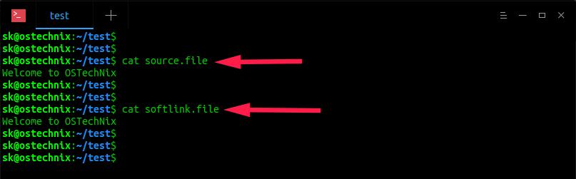

As you see in the above output, softlink.file displays the same data as source.file.

Let us check the inodes and permissions of softlink.file and source.file.

$ ls -lia

Sample output:

total 12

11665675 drwxrwxr-x 2 sk sk 4096 Oct 17 11:39 .

4325378 drwxr-xr-x 37 sk sk 4096 Oct 17 11:39 ..

11665731 lrwxrwxrwx 1 sk sk 11 Oct 17 11:39 softlink.file -> source.file

11665692 -rw-rw-r-- 1 sk sk 21 Oct 17 11:39 source.file

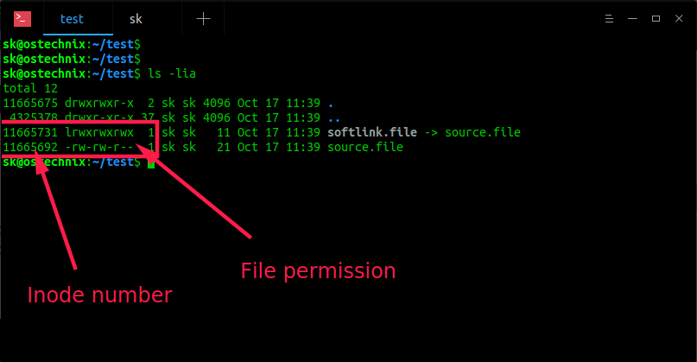

As we see in the above screenshot, the inode number (11665731 vs 11665692) and file permissions (lrwxrwxrwx vs -rw-r–r–) are different, even though the softlink.file has same contents as source.file, . Hence, it is proved that soft link don’t share the same inode number and permissions of original file.

Now, remove the original file (i.e source.file) and see what happens.

$ rm source.file

Check contents of the softlink.file using command:

$ cat softlink.file

Sample output:

cat: softlink.file: No such file or directory

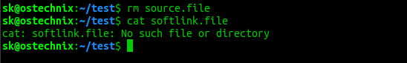

As you see above, there is no such file or directory called softlink.file after we removed the original file (i.e source.file). So, now we understand that soft link is just a link that points to the original file. The softlink is like a shortcut to a file. If you remove the file, the shortcut is useless.

As you already know, if you remove the soft link, the original file will still be available.

Suggested read:

* [How To List Symlinks On Linux](https://www.ostechnix.com/quick-tip-how-to-list-symlinks-on-linux/)
* [How To Find Broken Symlinks And Delete Them On Linux](https://www.ostechnix.com/how-to-find-broken-symlinks-and-delete-them-on-linux/)

#### Creating Hard Link

Create a file called source.file with some contents as shown below.

$ echo "Welcome to OSTechNix" >source.file

Let us verify the contents of the file.

$ cat source.file

Welcome to OSTechNix

source.file has been created now.

Now, let us create the hard link to the source.file as shown below.

$ ln source.file hardlink.file

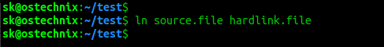

Check the contents of hardlink.file.

$ cat hardlink.file

Welcome to OSTechNix

You see the hardlink.file displays the same data as source.file.

Let us check the inode and permissions of hardlink.file and source.file.

$ ls -lia

Sample output:

total 16

11665675 drwxrwxr-x 2 sk sk 4096 Oct 17 11:58 .

4325378 drwxr-xr-x 37 sk sk 4096 Oct 17 11:39 ..

11665692 -rw-rw-r-- 2 sk sk 21 Oct 17 11:57 hardlink.file

11665692 -rw-rw-r-- 2 sk sk 21 Oct 17 11:57 source.file

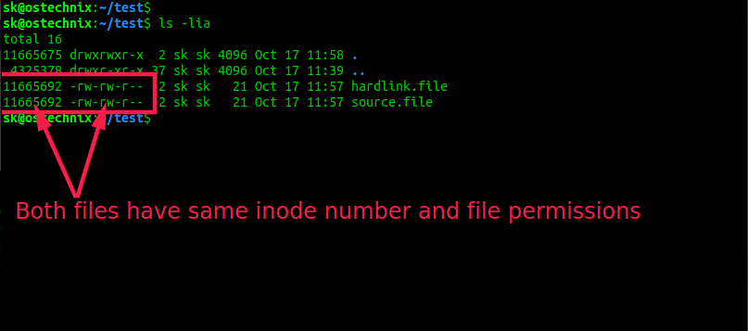

Now, we see that both hardlink.file and source.file have the same the inodes number (11665692) and file permissions (-rw-r–r–). Hence, it is proved that hard link file shares the same inodes number and permissions of original file.

Note: If we change the permissions on source.file, the same permission will be applied to the hardlink.file as well.

Now, remove the original file (i.e source.file) and see what happens.

$ rm source.file

Check contents of hardlink.file using command:

$ cat hardlink.file

Sample output:

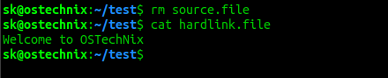

As you see above, even if I deleted the source file, I can view contents of the hardlink.file. Hence, it is proved that Hard link shares the same inode number, the permissions and data of the original file.

#### So, what is the difference between Hard link and the normal copied file?

You might be wondering why would we create a hard link while we can easily copy/paste the original file? Creating a hard link to a file is different than copying it.

If you copy a file, it will just duplicate the content. So if you modify the content of a one file (either original or hard link), it has no effect on the other one. However if you create a hard link to a file and change the content of either of the files, the change will be be seen on both.

Let us have a look at the source.file.

$ cat source.file

Welcome to OSTechNix

The source file has a single line that says – Welcome to OSTechNix.

Append a new line, for example “Welcome to Linux” in source.file or hardlink.file.

$ echo "Welcome to Linux" >>source.file

Now check contents of both files.

$ cat hardlink.file

Welcome to OSTechNix

Welcome to Linux

$ cat source.file

Welcome to OSTechNix

Welcome to Linux

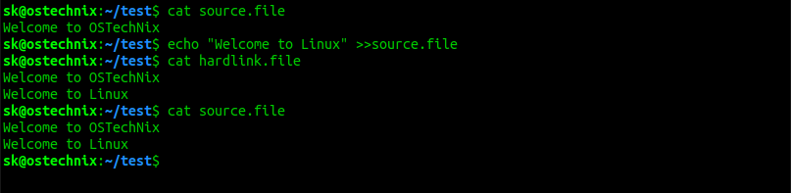

See? The changes we just made on source.file are updated in both files. Meaning – both files (source and hard link) synchronizes. Whatever changes you do in any file will be reflected on other one. If you normally copy/paste the file, you will not see any new changes in other file.

For more details, check the man pages.

$ man ln

**Linux Command Line Syntax**

Command typically have the syntax:

⇒ command option(s) arguments

**options:**

* Modify the way commands works
* Usually consists of hyphen or dash followed by single letter
* Some command accept multiple options which can usually be grouped together after a single hyphen

**Arguments:**

* Most commands are used with one or more arguments
* some commands assume a default argument if none is supplied
* Arguments are optional for some commands and required by others

command options argument

ls -ltr test

man <command> (to see options available with command)

**File Permission**

* Unix is a multi-user system . File and directory in your account can be protected or made accessible to other users by changing its access permissions.
* permission for file and directory may be restricted to by types
* there are three types of permission

1. r - read
2. w - write
3. x - execute(running a program)

* Each permission(rwx) can be control at 3 levels:

1. u - user = yourself
2. g -group = can be people on same project
3. o -other = everyone on the system

* Permission can be displayed by running **ls -l** command
* Command to change permission is **chmod**

**-rw-r--r-- 1 sandip sandip 8980 नवम्बर 18 2019 examples.desktop**

**-rw-r--r-- (**the first bit dash represents its a file**)**

Then 3 bits is the permission for who created the file (rw-)(user permission)

Next 3 bits represents permission groups the file (r--)(group permission)

Next three bit is the permission for other user who uses the system(r--)

**Commands**

**chmod g-w <filename> (**remove write permission for file for the group**)**

## **Ownership of Linux files**

**Every file and directory on your Unix/Linux system is assigned 3 types of owner, given below.**

### **User**

**A user is the owner of the file. By default, the person who created a file becomes its owner. Hence, a user is also sometimes called an owner.**

### **Group**

**A user- group can contain multiple users. All users belonging to a group will have the same access permissions to the file. Suppose you have a project where a number of people require access to a file. Instead of manually assigning permissions to each user, you could add all users to a group, and assign group permission to file such that only this group members and no one else can read or modify the files.**

### **Other**

**Any other user who has access to a file. This person has neither created the file, nor he belongs to a usergroup who could own the file. Practically, it means everybody else. Hence, when you set the permission for others, it is also referred as set permissions for the world.**

**Now, the big question arises how does Linux distinguish between these three user types so that a user 'A' cannot affect a file which contains some other user 'B's' vital information/data. It is like you do not want your colleague, who works on your Linux computer, to view your images. This is where Permissions set in, and they define user behavior.**

**Let us understand the Permission system on Linux.**

## **Permissions**

**Every file and directory in your UNIX/Linux system has following 3 permissions defined for all the 3 owners discussed above.**

* **Read: This permission give you the authority to open and read a file. Read permission on a directory gives you the ability to lists its content.**
* **Write: The write permission gives you the authority to modify the contents of a file. The write permission on a directory gives you the authority to add, remove and rename files stored in the directory. Consider a scenario where you have to write permission on file but do not have write permission on the directory where the file is stored. You will be able to modify the file contents. But you will not be able to rename, move or remove the file from the directory.**
* **Execute: In Windows, an executable program usually has an extension ".exe" and which you can easily run. In Unix/Linux, you cannot run a program unless the execute permission is set. If the execute permission is not set, you might still be able to see/modify the program code(provided read & write permissions are set), but not run it.**

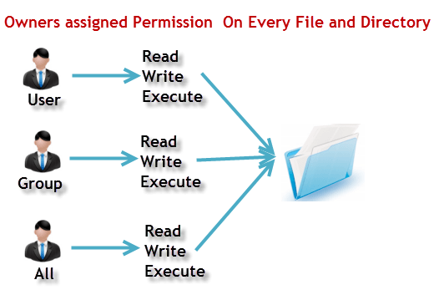 **Let's see this in action**

**ls - l on terminal gives**

**ls - l**

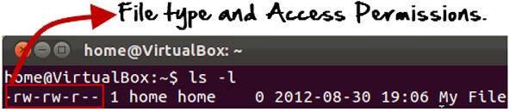

**Here, we have highlighted '-rw-rw-r--'and this weird looking code is the one that tells us about the permissions given to the owner, user group and the world.**

**Here, the first '-' implies that we have selected a file.p>**

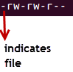

**Else, if it were a directory, d would have been shown.**

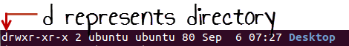

**The characters are pretty easy to remember.**

**r = read permission**

**w = write permission**

**x = execute permission**

**- = no permission**

**Let us look at it this way.**

**The first part of the code is 'rw-'. This suggests that the owner 'Home' can:**

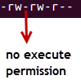

* **Read the file**
* **Write or edit the file**
* **He cannot execute the file since the execute bit is set to '-'.**

**By design, many Linux distributions like Fedora, CentOS, Ubuntu, etc. will add users to a group of the same group name as the user name. Thus, a user 'tom' is added to a group named 'tom'.**

**The second part is 'rw-'. It for the user group 'Home' and group-members can:**

* **Read the file**
* **Write or edit the file**

**The third part is for the world which means any user. It says 'r--'. This means the user can only:**

* **Read the file**

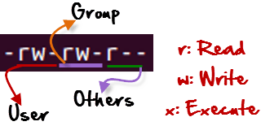

## **Changing file/directory permissions with 'chmod' command**

**Say you do not want your colleague to see your personal images. This can be achieved by changing file permissions.**

**We can use the 'chmod' command which stands for 'change mode'. Using the command, we can set permissions (read, write, execute) on a file/directory for the owner, group and the world. Syntax:**

**chmod permissions filename**

**There are 2 ways to use the command -**

1. **Absolute mode**
2. **Symbolic mode**

## **Absolute(Numeric) Mode**

**In this mode, file permissions are not represented as characters but a three-digit octal number.**

**The table below gives numbers for all for permissions types.**

| **Number** | **Permission Type** | **Symbol** |
| --- | --- | --- |
| **0** | **No Permission** | **---** |
| **1** | **Execute** | **--x** |
| **2** | **Write** | **-w-** |
| **3** | **Execute + Write** | **-wx** |
| **4** | **Read** | **r--** |
| **5** | **Read + Execute** | **r-x** |
| **6** | **Read +Write** | **rw-** |
| **7** | **Read + Write +Execute** | **rwx** |

**Let's see the chmod command in action.**

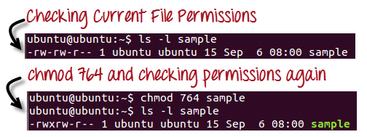

**In the above-given terminal window, we have changed the permissions of the file 'sample to '764'.**

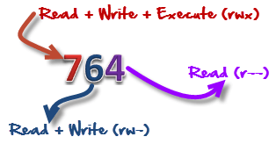

**'764' absolute code says the following:**

* **Owner can read, write and execute**
* **Usergroup can read and write**
* **World can only read**

**This is shown as '-rwxrw-r-**

**This is how you can change the permissions on file by assigning an absolute number.**

## **Symbolic Mode**

**In the Absolute mode, you change permissions for all 3 owners. In the symbolic mode, you can modify permissions of a specific owner. It makes use of mathematical symbols to modify the file permissions.**

| **Operator** | **Description** |
| --- | --- |
| **+** | **Adds a permission to a file or directory** |
| **-** | **Removes the permission** |
| **=** | **Sets the permission and overrides the permissions set earlier.** |

**The various owners are represented as -**

| **User Denotations** | |
| --- | --- |
| **u** | **user/owner** |
| **g** | **group** |
| **o** | **other** |
| **a** | **all** |

**We will not be using permissions in numbers like 755 but characters like rwx. Let's look into an example**

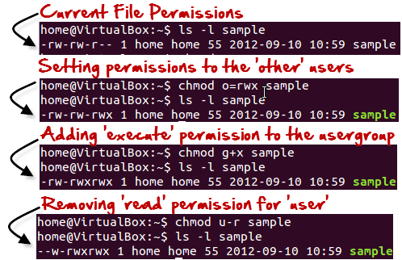

## **Changing Ownership and Group**

**For changing the ownership of a file/directory, you can use the following command:**

**chown user**

**In case you want to change the user as well as group for a file or directory use the command**

**chown user:group filename**

**Let's see this in action**

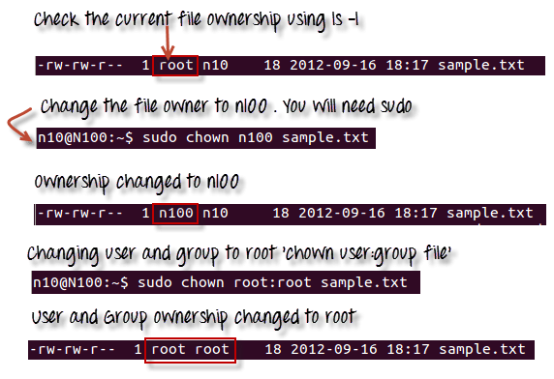

**In case you want to change group-owner only, use the command**

**chgrp group_name filename**

**'chgrp' stands for change group.**

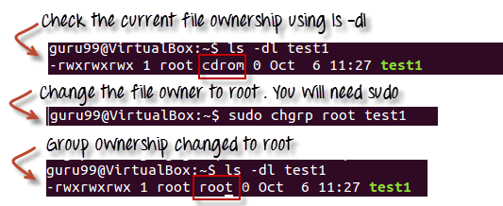

### **Tip**

* **The file /etc/group contains all the groups defined in the system**
* **You can use the command "groups" to find all the groups you are a member of**
* **You can use the command newgrp to work as a member a group other than your default group**
* 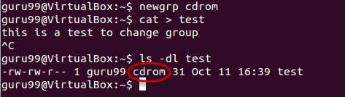**You cannot have 2 groups owning the same file.**
* **You do not have nested groups in Linux. One group cannot be sub-group of other**
* **x- eXecuting a directory means Being allowed to "enter" a dir and gain possible access to sub-dirs**
* **There are other permissions that you can set on Files and Directories which will be covered in a later advanced tutorial**

**To change group ownership of a directory and all of the files and subdirectories in that directory, use chgrp recursively.**

**chgrp -R new_group directory**

**Linux Help Commands**

There are three types of linux help commands:

* **whatis <command>**
* **<command> --help**
* **man command**

**Tab And Up arroyo Key**

**Adding Text to a Files**

* **vi(vim)**
* **Redirect command output using (>) or (>>) to a file**
* **echo (> ) or (>>) to file**

**> (will overdin if used on existing text file)**

**>> (will add on next line on existing text file)**

**Standard output to a file (tee command)**

**⇒ tee command is used to store and view(both at the same time) . It basically breaks the output of the program so that it can be both displayed and saved in a file. It does both task simultaneously.**

**echo “sandip neup” | tee <filname>**

**cat “sandip” | tee -a <file_name> (appends to a file)**

**ls -l | tee <file_name1> <filename2> (prints results of ls -l in multiple files)**

To count the words from file:

**wc -c <file_name>**

**Pipes(|)**

**⇒** A pipe is used by shell to connect output of one command directly to the input of another command

The symbol for pipe is vertical bar ( | ). The command syntax is

**Command [arguments ] | command2 arguemnts**

If you have multiple lines of output of command you can use more command to see one page at a time

Eg: **ls -l | more**

**To get the last line of te command**

**ls -l | tail -1**

**File Maintenance Commands(cp, mv ,rmdir mkdir, rm)**

* **cp (cp <source> <destination>)**
* **mv (rename and move) (mv <source> <destination>)**
* **Rmdir or rm -r (rmdir <file_to_remove>)**
* **Mkdir**
* **rm (rm <file_to_remove>)**
* **chgrp**
* **chown**

**rm -Rf will remove directory and subdirectory forcefully**

**File Display Commands:**

* **cat**
* **more (more)**
* **less**
* **head**
* **tail (tail -<no_of_lines> <filename>)**

**Filter or text process commands**

* **cut**

eg: cut -c1 <filename>

cuts 1st letter from each line in file filename

**cut -c1-3 <file_name>**

Prints first three character from each line of <file_name>

* **awk**

**awk** separate each column in a file

eg: **awk ‘(print $1) <filename>**

prints first column of <filename>

**awk ‘(print $2) <filename>**

Prints second column of <file_name>

* **grep**

It’s like searching a character in a file.

**grep <character> <filename>**

* **sort**

**sorts the line in file**

**sort <filename>**

Sorts in alphabetical order

sort -r <filename>

Sort in reverse order

* **uniq**

Always use sort before uniq

**sort <filename> | uniq**

**uniq** removes all the duplicates from a file

uniq <file_name>

* **wc**

word count counts the character lines in file

wc <file_name>

17 34 345 <file_name>(output)

Line character file_siz**e**

**Compare Files**

* **diff** ( Compares line by line )

diff <file1> <file2>

* **cmp** (Compares byte by byte)

**Compress and Uncompress files**

* **tar**

Compress the file but gzip compresses more then tar.

tar -cvf <file_name> <directory_want_to_tar>

**untar**

tar -xvf <file-name>

* **gzip**

**gzip <file_name>**

* **gunzip or gzip -d (uncompress)**

**gzip -d <file_name> <where_to>**

**or**

**gunzip <file_name>**

**Truncate Command:**

Linux truncate command is used to shrink the file.

Truncate looses the content of the file.

**truncate -s <size> <file_name>**

**Truncate can also be used to increase file size**

**truncate -s <size_greater_then_previous> <file_name>**

**Combining and splitting files**

**cat file1 file2 file3 > file4 (combining)**

**split -l 300 files.txt childfile**

Splits files.txt in every 300 lines

## **VI Editing commands**

* i - Insert at cursor (goes into insert mode)
* a - Write after cursor (goes into insert mode)
* A - Write at the end of line (goes into insert mode)
* ESC - Terminate insert mode
* u - Undo last change
* U - Undo all changes to the entire line
* o - Open a new line (goes into insert mode)
* dd - Delete line
* 3dd - Delete 3 lines.
* D - Delete contents of line after the cursor
* C - Delete contents of a line after the cursor and insert new text. Press ESC key to end insertion.
* dw - Delete word
* 4dw - Delete 4 words
* cw - Change word
* x - Delete character at the cursor
* r - Replace character
* R - Overwrite characters from cursor onward
* s - Substitute one character under cursor continue to insert
* S - Substitute entire line and begin to insert at the beginning of the line
* ~ - Change case of individual character

**Note**: You should be in the "**command mode" to execute these commands**. VI editor is **case-sensitive** so make sure you type the commands in the right letter-case.

Make sure you press the right command otherwise you will end up making undesirable changes to the file. You can also enter the insert mode by pressing a, A, o, as required.

## **Moving within a file**

* k - Move cursor up
* j - Move cursor down
* h - Move cursor left
* l - Move cursor right

You need to be in the command mode to move within a file. The default keys for navigation are mentioned below else; You can **also use the arrow keys on the keyboard**.

## **Saving and Closing the file**

* Shift+zz - Save the file and quit
* :w - Save the file but keep it open
* :q - Quit without saving
* :wq - Save the file and quit

You should be in the **command mode to exit the editor and save changes**

to the file

: %s /sandip/sanip

Replace evry character sandip by sanip

**Sed Command**

* Replace a string in file with new string

**sed ‘s/<replace_string_name>/<new_string>/g’ <file_name>**

Here, /g means globally in a file .sed display the change in output not in actual file.

**-i** to insert the change in the file

**sed -i ‘s/<replace_string>/<with_new_string>/g’ <of_file_name>**

* Find and delete line

**sed ‘s/<string_to_delte>//g’ <file_name>**

Finds the string and replace with nothing

**sed ‘/<string>/d’ <file_name>**

Removes every line of file <file_name> that has <string>

* Remove empty lines

**sed ‘/^$/d’ <file_name>**

Removes the empty line

* Remove a first line or n lines in file

**sed ‘1d’ <file_name>**

Removes first line of the file

**sed ‘1,2d’ <file_name>**

**Removes 1st and 2nd line**

**sed ‘s/\t/ /g’ <file_name>**

Substitute every tabs with space

* Show defined lines from a file

**sed -n 12,18p <file_name>**

show line 12 to 18 from the file

**sed 12,18d <file_name>**

**Shows line other then between 12-18**

**sed -G <file_name>**

Adds empty line after every line

**sed ‘!8s/sandip/sanip/g’ <file_name>**

Replace every string matching **‘sandip’** in <file_name> with **‘sanip’**

except line 8.

**User Account Management**

* useradd

**useradd sandip**

Creates user with username sandip

To verify user is created

**id username**

* groupadd

**groupadd <group_name>**

To verify that the group is created you can do

**cat /etc/group**

**superhero:x:1002:**

* userdel

**userdel <user_name>**

To delete the home directory that is created with user use:

userdel -r <username>

* groupdel

groupdel <group_name>

* usermod

**Files**

* **/etc/passwd**
* **/etc/group**
* **/etc/shadow**

**useradd -g <group_name> -s <shell> -c <description> -m -d <specify_home_directory>**

**useradd -g superhero -s bin/bash -c “Creating Ironman” -m -d /home/user**

**Switch User And Sudo Access**

Commands

* su - username
* sudo (sudo followed by the command to give root access to command)
* visudo

The sudo command is configured through a file located at /etc/sudoers.

Because improper syntax in the /etc/sudoers file can leave you with a system where it is impossible to obtain elevated privileges, it is important to use the visudo command to edit the file.

The visudo command opens a text editor like normal, but it validates the syntax of the file upon saving. This prevents configuration errors from blocking sudo operations, which may be your only way of obtaining root privileges.

Traditionally, visudo opens the /etc/sudoers file with the vi text editor. Ubuntu, however, has configured visudo to use the nano text editor instead.

## **How To Give a User Sudo Privileges**

The most common operation that users want to accomplish when managing sudo permissions is to grant a new user general sudo access. This is useful if you want to give an account full administrative access to the system.

The easiest way of doing this on a system set up with a general purpose administration group, like the Ubuntu system in this guide, is actually to just add the user in question to that group.

For example, on Ubuntu 16.04, the sudo group has full admin privileges. We can grant a user these same privileges by adding them to the group like this:

* sudo usermod -aG sudo username

The gpasswd command can also be used:

* sudo gpasswd -a username sudo

**Monitor User**

* **who**
* **last**
* **w**
* **finger**
* **id**

**Talking to User**

**$users to see the logged in users**

* **users**
* **wall(wall send message to all login users)**
* **write (writes message to specific user)**

**write <username>**

**Linux Account Authentication**

Types of account:

* Local account
* Domain or directory account

**System Utility Commands**

* **date**
* **uptime**

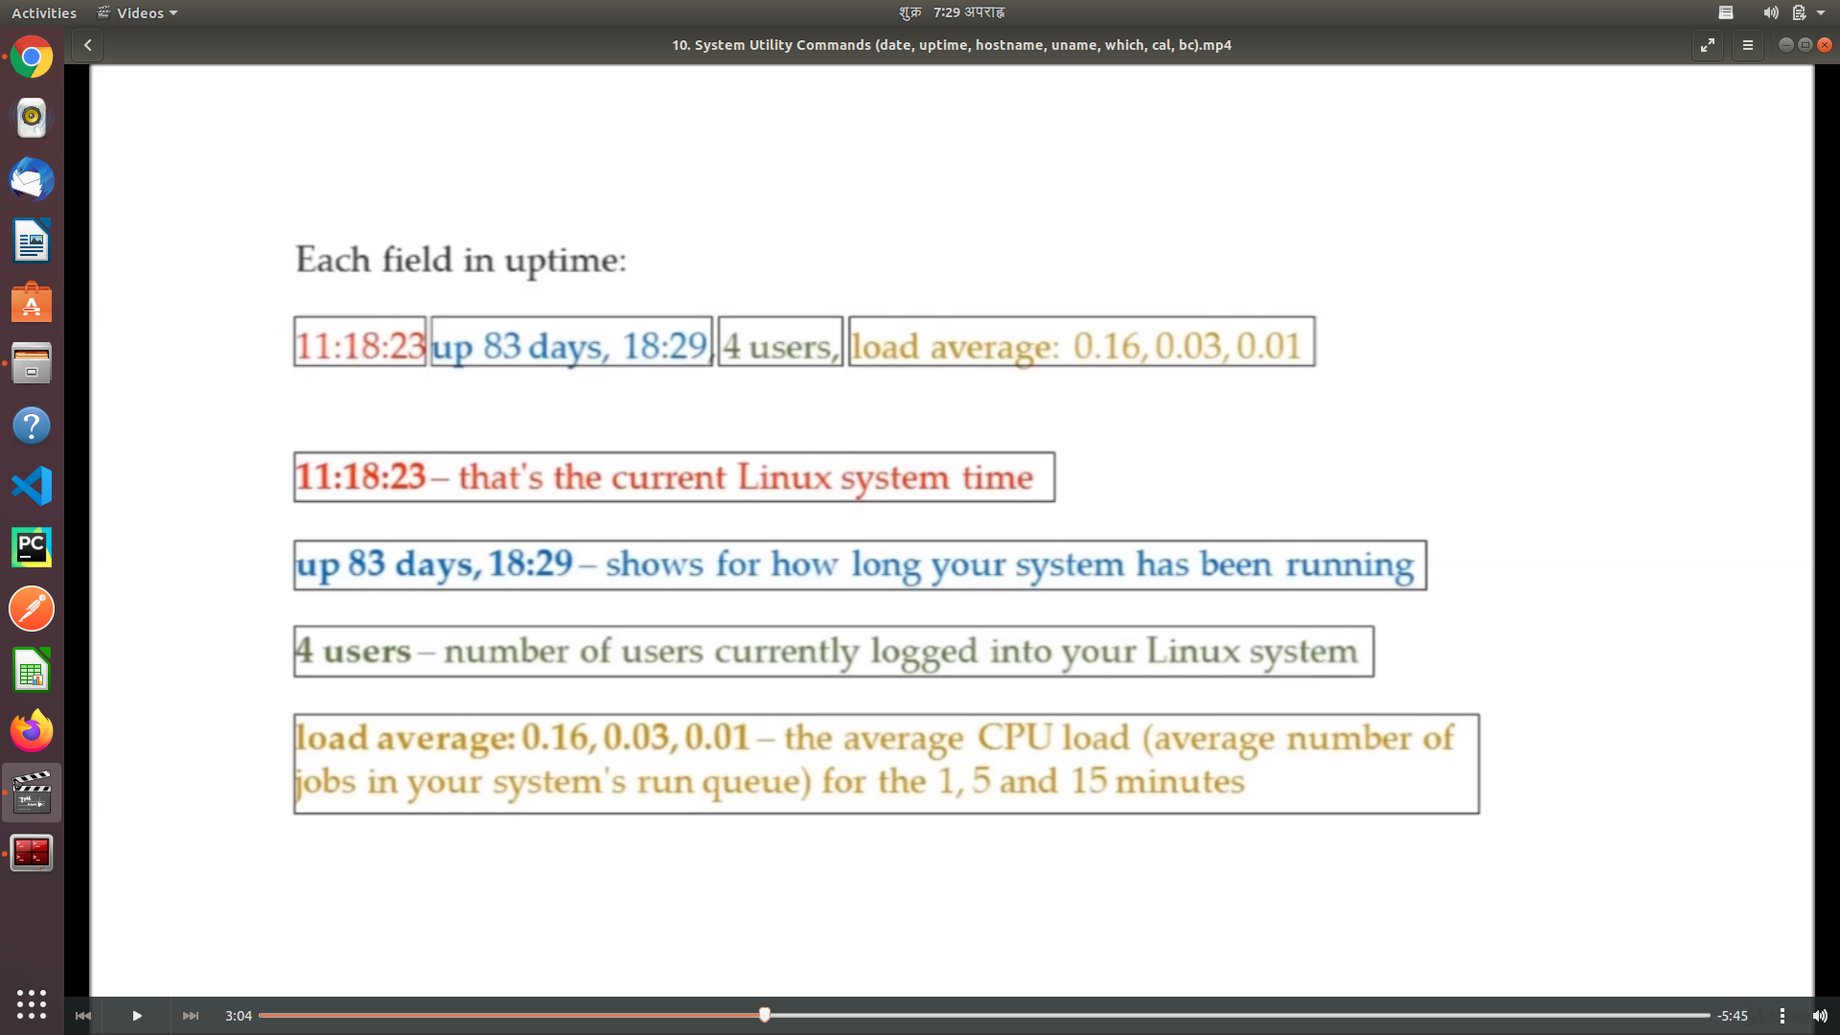

* **hostname**

Gives hostname of linux machine

* **uname**
* **which**

**which <command>**

Shows command location

* **cal**

Gives calender

**cal (gives current month)**

**Cal <year> (gives calender of whole year)**

**cal <month> <year> (**gives calender of certain month of year**)**

* **bc (binary calculator)**

**Process and Jobs**

**Process or service commands**

* **systemctl or service (command to start stop application, also enables to start application at boot time)**

**systemctl status <process_name> (checks if the process is running)**

* **ps (shows running process)**
* **top (shows running process with extra information like cpu load)**
* **kill (used to kill process)**
* **crontab (used to schedule)**
* **at (used to schedul)**

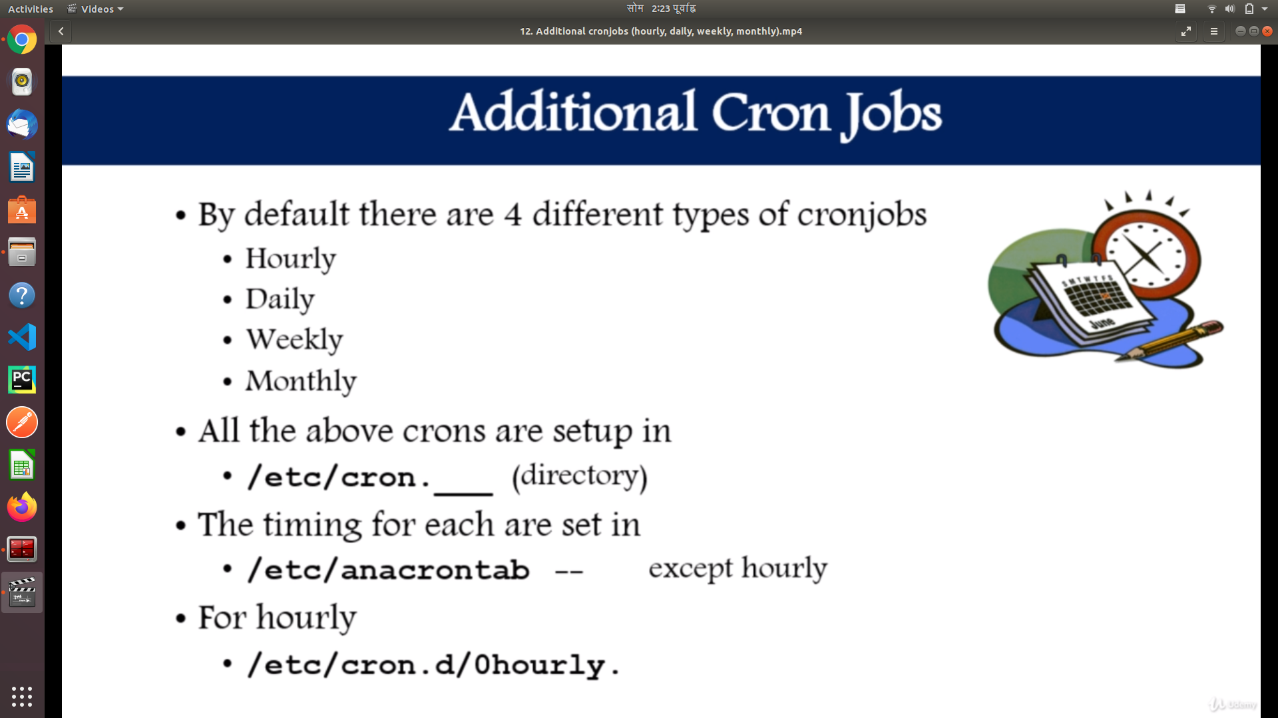

**ls -l /etc | grep cron**

-rw-r--r-- 1 root root 401 मई 29 2017 anacrontab

drwxr-xr-x 2 root root 4096 जनवरी 24 10:18 cron.d

drwxr-xr-x 2 root root 4096 मई 15 09:54 cron.daily

drwxr-xr-x 2 root root 4096 अगस्त 6 2019 cron.hourly

drwxr-xr-x 2 root root 4096 अगस्त 6 2019 cron.monthly

-rw-r--r-- 1 root root 722 नवम्बर 16 2017 crontab

drwxr-xr-x 2 root root 4096 अगस्त 6 2019 cron.weekly

If you want to run some script to daily move your script file on cron.daily folder.

The timing when the scripts run will be specified in anacrontab.

**Process Management**

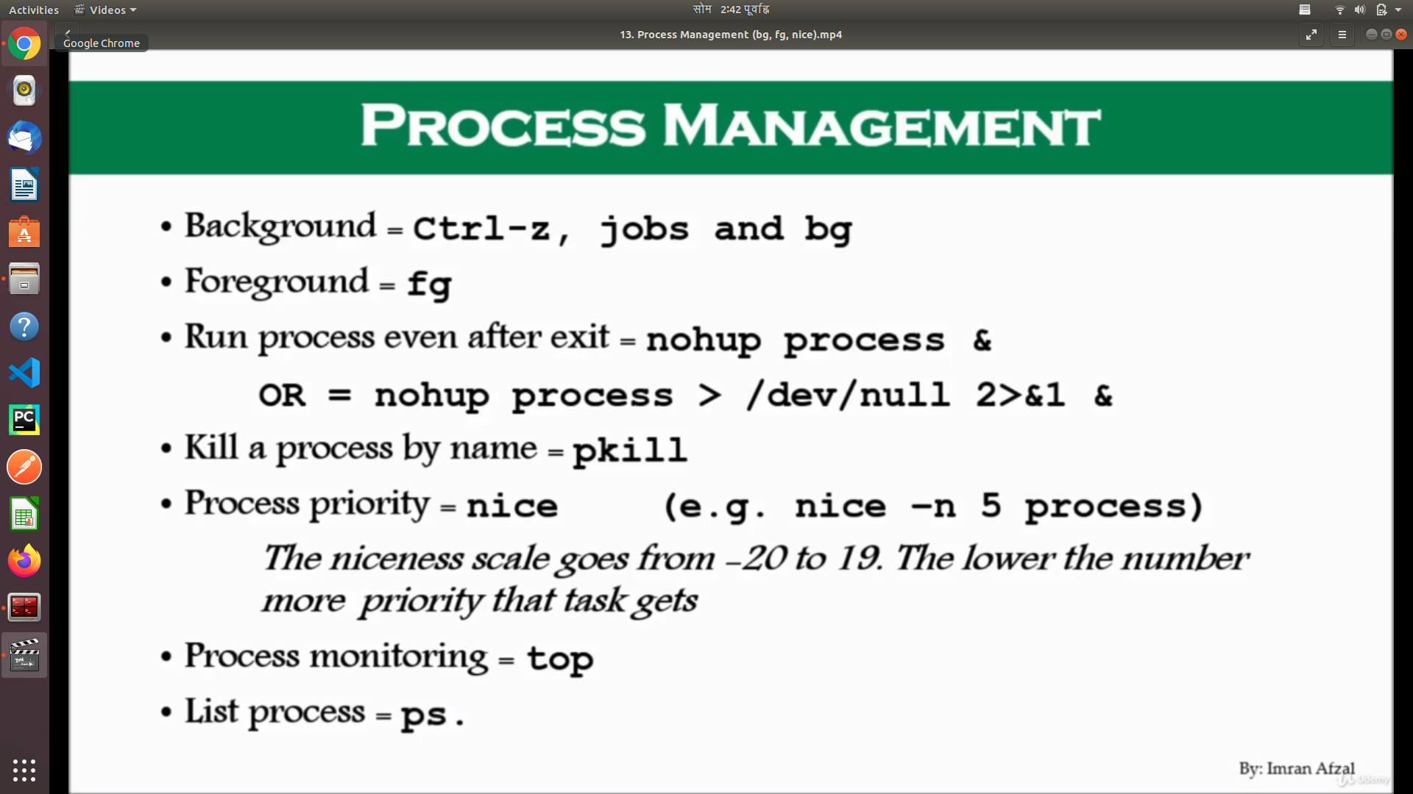

**System Monitoring Commands**

* top
* df (shows disk usage)
* dmesg (gives you ebios information everything related to system hardware will be listed here)
* iostat (input and output statistics)

Iostat 1 (refreshes every one second)

* netstat

(what is connected to the system what is disconnected from the system)

netstat -rnv (to get getway , subnetmask)

* free (Display amount of free and used memory in the system)
* cat /proc /cpuinfo (gives cpu information)
* cat /proc/meminfo (gives memory information)

**System Log Monitoring**

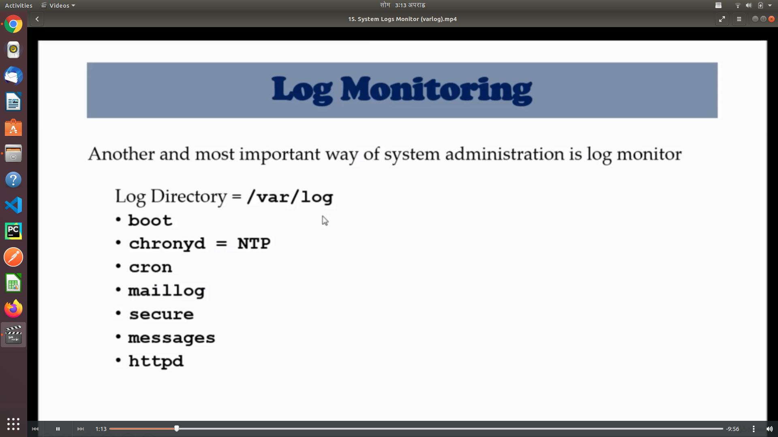

## **What are Linux log**

## **files**

Log files are a set of records that Linux maintains for the administrators to keep track of important events. They contain messages about the server, including the kernel, services and applications running on it.

Linux provides a centralized repository of log files that can be located under the /var/log directory.

The log files generated in a Linux environment can typically be classified into four different categories:

* Application Logs
* Event Logs
* Service Logs
* System Logs

## **Why monitor Linux log**

## **files**

Log management is an **integral part** of any server administrator’s responsibility.

By monitoring Linux log files, you can gain detailed insight on server performance, security, error messages and underlying issues by. If you want to take a proactive vs. a reactive approach to server management, regular log file analysis is 100% required.

In short, log files allow you to **anticipate upcoming issues** before they actually occur.

## **Which Linux log files to**

## **monitor**

Monitoring and analyzing all of them can be a challenging task.

The sheer volume of logs can sometimes make it frustrating just to drill down and find the right file that contains the desired information.

To make it a little easier for you, we will introduce you to some of the most critical Linux log files that you must be monitoring.

Note: Please note that this is not an all-inclusive list - but just a subset of the important log files that matter the most. The more you can handle, the better it is for the health of your server. Listed below are the bare minimum that you must monitor without fail

## **/var/log/**

## **messages**

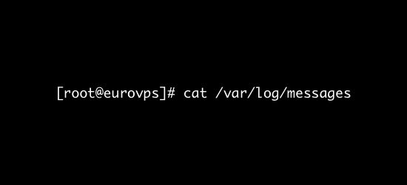

### **What’s logged here?:**

* This log file contains generic system activity logs.
* It is mainly used to store informational and non-critical system messages.
* In Debian-based systems, /var/log/syslog directory serves the same purpose.

### **How can I use these logs?:**

* Here you can track non-kernel boot errors, application-related service errors and the messages that are logged during system startup.
* This is the first log file that the Linux administrators should check if something goes wrong.
* For example, you are facing some issues with the sound card. To check if something went wrong during the system startup process, you can have a look at the messages stored in this log file.

## **/var/log/auth.log**

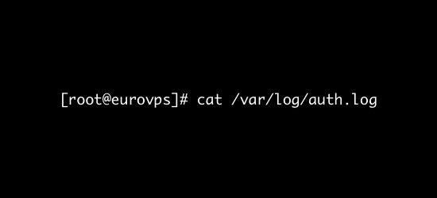

### **What’s logged here?**

* All authentication related events in Debian and Ubuntu server are logged here.
* If you’re looking for anything involving the user authorization mechanism, you can find it in this log file.

### **How can I use these logs?:**

Suspect that there might have been a security breach in your server? Notice a suspicious javascript file where it shouldn’t be? If so, then find this log file asap!

* Investigate failed login attempts
* Investigate brute-force attacks and other vulnerabilities related to user authorization mechanism.

## ***/var/log/secure***

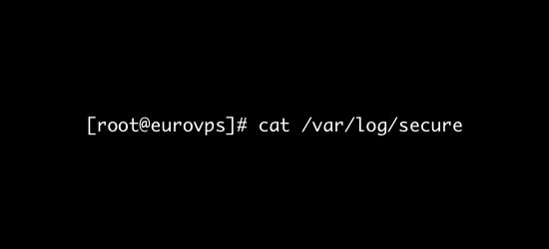

### **What’s logged here?**

RedHat and CentOS based systems use this log file instead of /var/log/auth.log.

* It is mainly used to track the usage of authorization systems.
* It stores all security related messages including authentication failures.
* It also tracks sudo logins, SSH logins and other errors logged by system security services daemon.

### **How can I use these logs?:**

* All user authentication events are logged here.
* This log file can provide detailed insight about unauthorized or failed login attempts
* Can be very useful to detect possible hacking attempts.
* It also stores information about successful logins and tracks the activities of valid users.

## ***/var/log/boot.log***

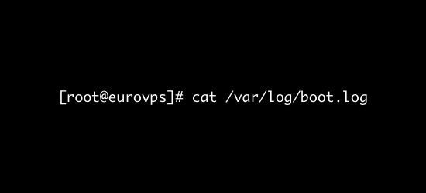

### **What’s logged here?**

* The system initialization script, /etc/init.d/bootmisc.sh, sends all bootup messages to this log file
* This is the repository of booting related information and messages logged during system startup process.

### **How can I use these logs?:**

* You should analyze this log file to investigate issues related to improper shutdown, unplanned reboots or booting failures.
* Can also be useful to determine the duration of system downtime caused by an unexpected shutdown.

## ***/var/log/*dmesg**

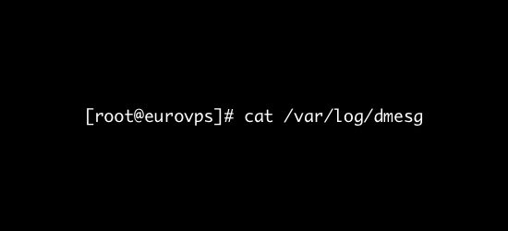

### **What’s logged here?**

* This log file contains Kernel ring buffer messages.
* Information related to hardware devices and their drivers are logged here.
* As the kernel detects physical hardware devices associated with the server during the booting process, it captures the device status, hardware errors and other generic messages.

### **How can I use these logs?:**

* This log file is useful for dedicated server customers mostly.
* If a certain hardware is functioning improperly or not getting detected, then you can rely on this log file to troubleshoot the issue.
* Or, you can purchase a [managed server](https://www.eurovps.com/dedicated-servers) from us and we’ll monitor it for you.

## ***/var/log/kern.log***

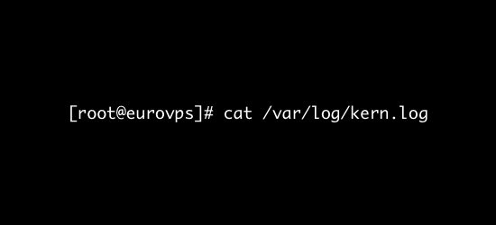

### **What’s logged here?**

This is a very important log file as it contains information logged by the kernel.

### **How can I use these logs?:**

* Perfect for troubleshooting kernel related errors and warnings.
* Kernel logs can be helpful to troubleshoot a custom-built kernel.
* Can also come handy in debugging hardware and connectivity issues.

## ***/var/log/*faillog**

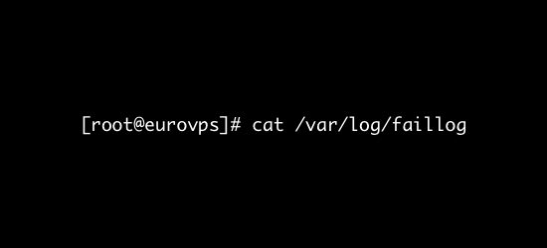

### **What’s logged here?**

This file contains information on failed login attempts.

### **How can I use these logs?:**

It can be a useful log file to find out any attempted security breaches involving username/password hacking and brute-force attacks.

## ***/var/log/*cron**

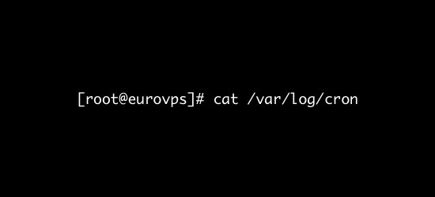

### **What’s logged here?**

This log file records information on cron jobs.

### **How can I use these logs**

* Whenever a cron job runs, this log file records all relevant information including successful execution and error messages in case of failures.
* If you’re having problems with your scheduled cron, you need to check out this log file.

## ***/var/log/yum.log***

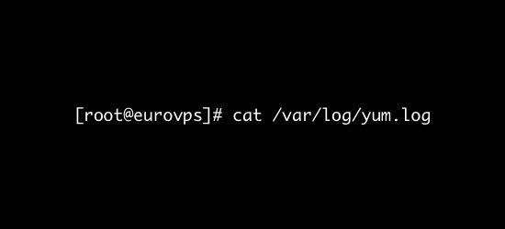

### **What’s logged here?**

It contains the information that is logged when a new package is installed using the yum command.

### **How can I use these logs?:**

* Track the installation of system components and software packages.
* Check the messages logged here to see whether a package was correctly installed or not.
* Helps you troubleshoot issues related to software installations.

Suppose your server is behaving unusually and you suspect a recently installed software package to be the root cause for this issue. In such cases, you can check this log file to find out the packages that were installed recently and identify the malfunctioning program.

## ***/var/log/*maillog *or /var/log/mail.log***

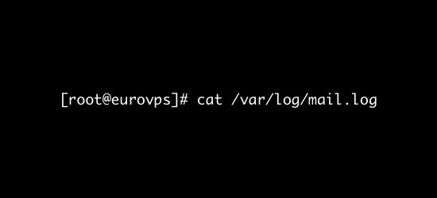

### **What’s logged here?**

All mail server related logs are stored here.

### **How can I use these logs?**

* Find information about postfix, smtpd, MailScanner, [SpamAssassain](https://www.eurovps.com/blog/how-to-prevent-spam-in-cpanel-plesk) or any other email related services running on the mail server.
* Track all the emails that were sent or received during a particular period
* Investigate failed mail delivery issues.
* Get information about possible spamming attempts blocked by the mail server.
* Trace the origin of an incoming email by scrutinizing this log file.

## ***var/log/httpd/***

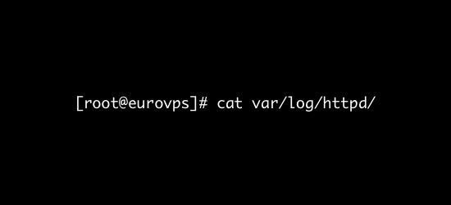

### **What’s logged here?**

* This directory contains the logs recorded by the Apache server.
* Apache server logging information are stored in two different log files – error_log and access_log.

### **How can I use these logs?:**

* The error_log contains messages related to httpd errors such as memory issues and other system related errors.
* This is the place where Apache server writes events and error records encountered while processing httpd requests.
* If something goes wrong with the Apache webserver, check this log for diagnostic information.
* Besides the error-log file, Apache also maintains a separate list of access_log.
* All access requests received over HTTP are stored in the access_log file.
* Helps you keep track of every page served and every file loaded by Apache.
* Logs the IP address and user ID of all clients that make connection requests to the server.
* Stores information about the status of the access requests, – whether a response was sent successfully or the request resulted in a failure.

## **/var/log/mysqld.log or /var/log/mysql.log**

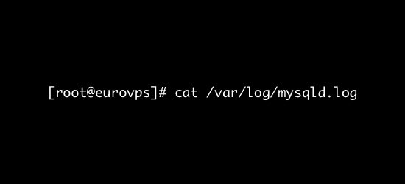

### **What’s logged here?**

* As the name suggests, this is the MySQL log file.
* All debug, failure and success messages related to the [mysqld] and [mysqld_safe] daemon are logged to this file.
* RedHat, CentOS and Fedora stores MySQL logs under /var/log/mysqld.log, while Debian and Ubuntu maintains the log in /var/log/mysql.log directory.

### **How can I use this log?**

* Use this log to identify problems while starting, running, or stopping mysqld.
* Get information about client connections to the MySQL data directory
* You can also setup ‘long_query_time’ parameter to log information about query locks and slow running queries.

**System Maintenance Command**

* **shutdown**

**The shutdown command brings the system down in a secure way. All** [**logged-in**](https://www.computerhope.com/jargon/l/login.htm) **users are notified that the system is going down, and** [**login**](https://www.computerhope.com/unix/ulogin.htm) **operations are blocked.**

## **Examples**

**shutdown 8:00**

**Schedule the system to shut down at 8 A.M.**

**shutdown 20:00**

**Schedule the system to shut down at 8 P.M.**

**shutdown +15 "Upgrading hardware, downtime should be minimal"**

**Schedule the system to shut down in fifteen minutes. Along with the normal message alerting users that the system is shutting down, they will be given the descriptive message about a hardware upgrade.**

**shutdown now**

**Bring down the system immediately.**

**shutdown -r now**

**Bring down the system immediately, and automatically reboot it.**

**shutdown -P now**

**Bring down the system immediately, and automatically power off the system.**

* **init 0-6**

# init

**It is the first process executed by the kernel during the booting of a system. It is a daemon process which runs till the system is shutdown. That is why, it is the parent of all the processes. First of all, init reads the script stored in the file /etc/inittab. Command init reads the initial configuration script which basically take care of everything that a system do at the time of system initialization like setting the clock, initializing the serial port and so on.**

**By reading this file, init determines how the system should be set up in each runlevel and sets default run level.**

**After determining default runlevel for the system, init starts all background processes required to run the system. First it runs each of the kill script (their file name starts with a K) with a stop parameter. Then it runs all start scripts (their file name starts with an S) to start all services and applications.**

## Runlevels

**A runlevel is a software configuration of Linux system which permits only a selected group of processes to exist. It defines what services are operating on the system.**

**Runlevels are identified by numbers. init can be in one of eight runlevels. It is changed by a privileged user run telinit, which sends appropriate signals to init to change runlevel.**

| **Runlevel** | **Function** |
| --- | --- |
| **0** | **Halt the system** |
| **1** | **Single user mode** |
| **2** | **Multiuser mode without networking** |
| **3** | **Multiuser mode with networking** |
| **4** | **Not used** |
| **5** | **Multiuser with networking and X windows** |
| **6** | **Reboot the system** |
| **S/s** | **Not used directly** |

* **0,1 and 6 are reserved runlevels.**
* **Runlevel S or s are same.**
* **7-9 are also valid runlevels, though they are not documented as traditional Unix variants, do'nt use them. But they are same as runlevels S or s. They are aliased.**

## Changing runlevels

**There are many ways to change runlevels. To make the changes permanently, change the default level in the file /etc/inittab.**

**After all the processes, init waits for one of its descendent process to die, for a powerfail signal. Or wait until telinit signals to change the runlevel. When above conditions occur, it re-examines the /etc/inittab file. New entries can be added to this file any time.**

**When init is not in single user mode and receives a power fail signal (SIGPWR), it reads the file /etc/powerstatus. Based on the content of this file, init starts a command:**

* **F (FAIL) ? When power fails, UPS provides the power. Execute the powerfail and powerwait entries.**
* **O (OK) ? Power has been restored, execute powerokwait entries.**
* **L (LOW) ? Power is degrading and UPS has a low battery, executes powerfailnow entries.**

**If file /etc/powerstatus doesn't exist or contains anything other than F, O, L, then init behaves as if it has read the letter F.**

**To interact with init, /dev/initctl control channel should be used rather than SIGPWR and /etc/powerstatus.**

**When a request to change the runlevel is send to init, init sends warning signal SIGTERM to all the undefined processes in the new runlevel. It then waits for 5 seconds before terminating processes via SIGKILL forcibly.**

**All these processes should remain in the same process group which was created by the init, otherwise they will not be able to receive these signals and they need to be terminated separately.**

## Telinit

**/sbin/telinit is linked up with /sbin/init. Telinit takes up an argument and signals init to perform the respective function.**

**Arguments are as follows with are one character each:**

| **Argument** | **Function** |
| --- | --- |
| **0,1,2,3,4,5,6** | **Switch to specified runlevel** |
| **a,b,c** | **Processes only file entries from /etc/inittab having runlevel a,b,c.** |
| **Q or q** | **Re-examine file /etc/inittab** |
| **S or s** | **Switch to single user mode** |
| **U or u** | **init re-execute itself. No re-examine occurs, runlevel should be from S,s,1,2,3,4,5 otherwise request would be ignored silently.** |

**Default time to wait between sending the signals SIGTERM and SIGKILL is 5 seconds, but telinit can also ask init to change this time with the option -t sec.**

**Only users having appropriate privileges can execute telinit.**

**The init binary checks by the process ID whether it is init or telinit, init's process ID is always 1. so one can also use init instead of telinit as shortcut**

* **reboot**
* **halt**

**Changing System Hostname**

* **hostnamectl - set-hostname newHostname**

**Finding System Information**

* **cat**

**If ubuntu**

**cat /etc/os-release**

**Cat /etc/lsb-release**

**If RedHat**

**cat /etc/redhat-release**

* **uname -a**
* **dmidecode (gives information about processor hardware underneath os)**

**System Architecture**

32 vs 64 bit architecture

To find your linux architecture use command:

**arch**

**Terminal control key**

### Ctrl + C

These are the keys you should press in order to break out of a command or process on a terminal. This will stop a running program immediately.

If you want to stop using a program running in the foreground, just press this key combination.

### Ctrl + Z

This shortcut will send a running program in the background. Normally, you can achieve this before running the program using the & option but if you forgot to do that, use this key combination.

### Ctrl + D

This keyboard shortcut will log you out of the current terminal. If you are using an [SSH](https://www.ssh.com/ssh/protocol/) connection, it will be closed. If you are using a terminal directly, the application will be closed immediately.

### Ctrl + L

How do you clear your terminal screen? I guess using the clear command.

Instead of writing C-L-E-A-R, you can simply use Ctrl+L to clear the terminal. Handy, isn’t it?

### Ctrl + A

This shortcut will move the cursor to the beginning of the line.

### Ctrl + E

This shortcut is sort of opposite to Ctrl+A. Ctrl+A sends the cursor to the beginning of the line whereas Ctrl+E moves the cursor to the end of the line.

### Ctrl + U

use Ctrl+U shortcut in the Linux terminal. This shortcut erases everything from the current cursor position to the beginning of the line.

### Ctrl + K

This one is similar to the Ctrl+U shortcut. The only difference is that instead of the beginning of the line, it erases everything from the current cursor position to the end of the line.

### Ctrl + W

if you just need to delete a single word Use the Ctrl+W shortcut.

### Ctrl + Y

This will paste the erased text that you saw with Ctrl + W, Ctrl + U and Ctrl + K shortcuts.

### Ctrl + P

You can use this shortcut to view the previous command. You can press it repeatedly to keep on going back in the command history. In a lot of terminals, the same can be achieved with PgUp key.

### Ctrl + N

You can use this shortcut in conjugation with Ctrl+P. Ctrl+N displays the next command. If you are viewing previous commands with Ctrl+P, you can use Ctrl+N to navigate back and forth. Many terminals have this shortcut mapped to the PgDn key.

**Linux Terminal Commands**

* **clear**
* **exit**
* **script**

**Eg: script**

**And then run your commands your commands output will be saved in typescript file**

**Eg script <file_name>**

**Keeps your command log in <file_name> file**

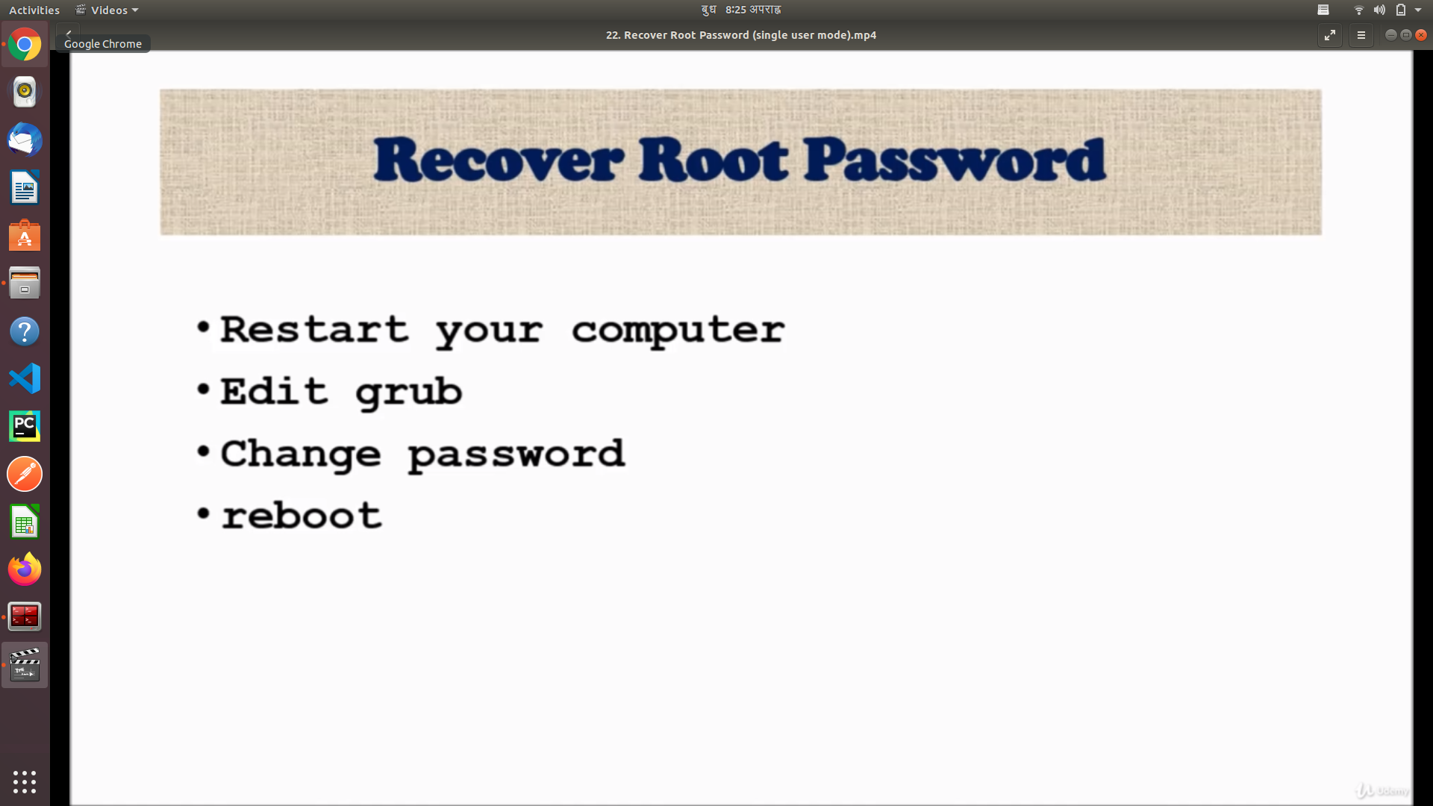

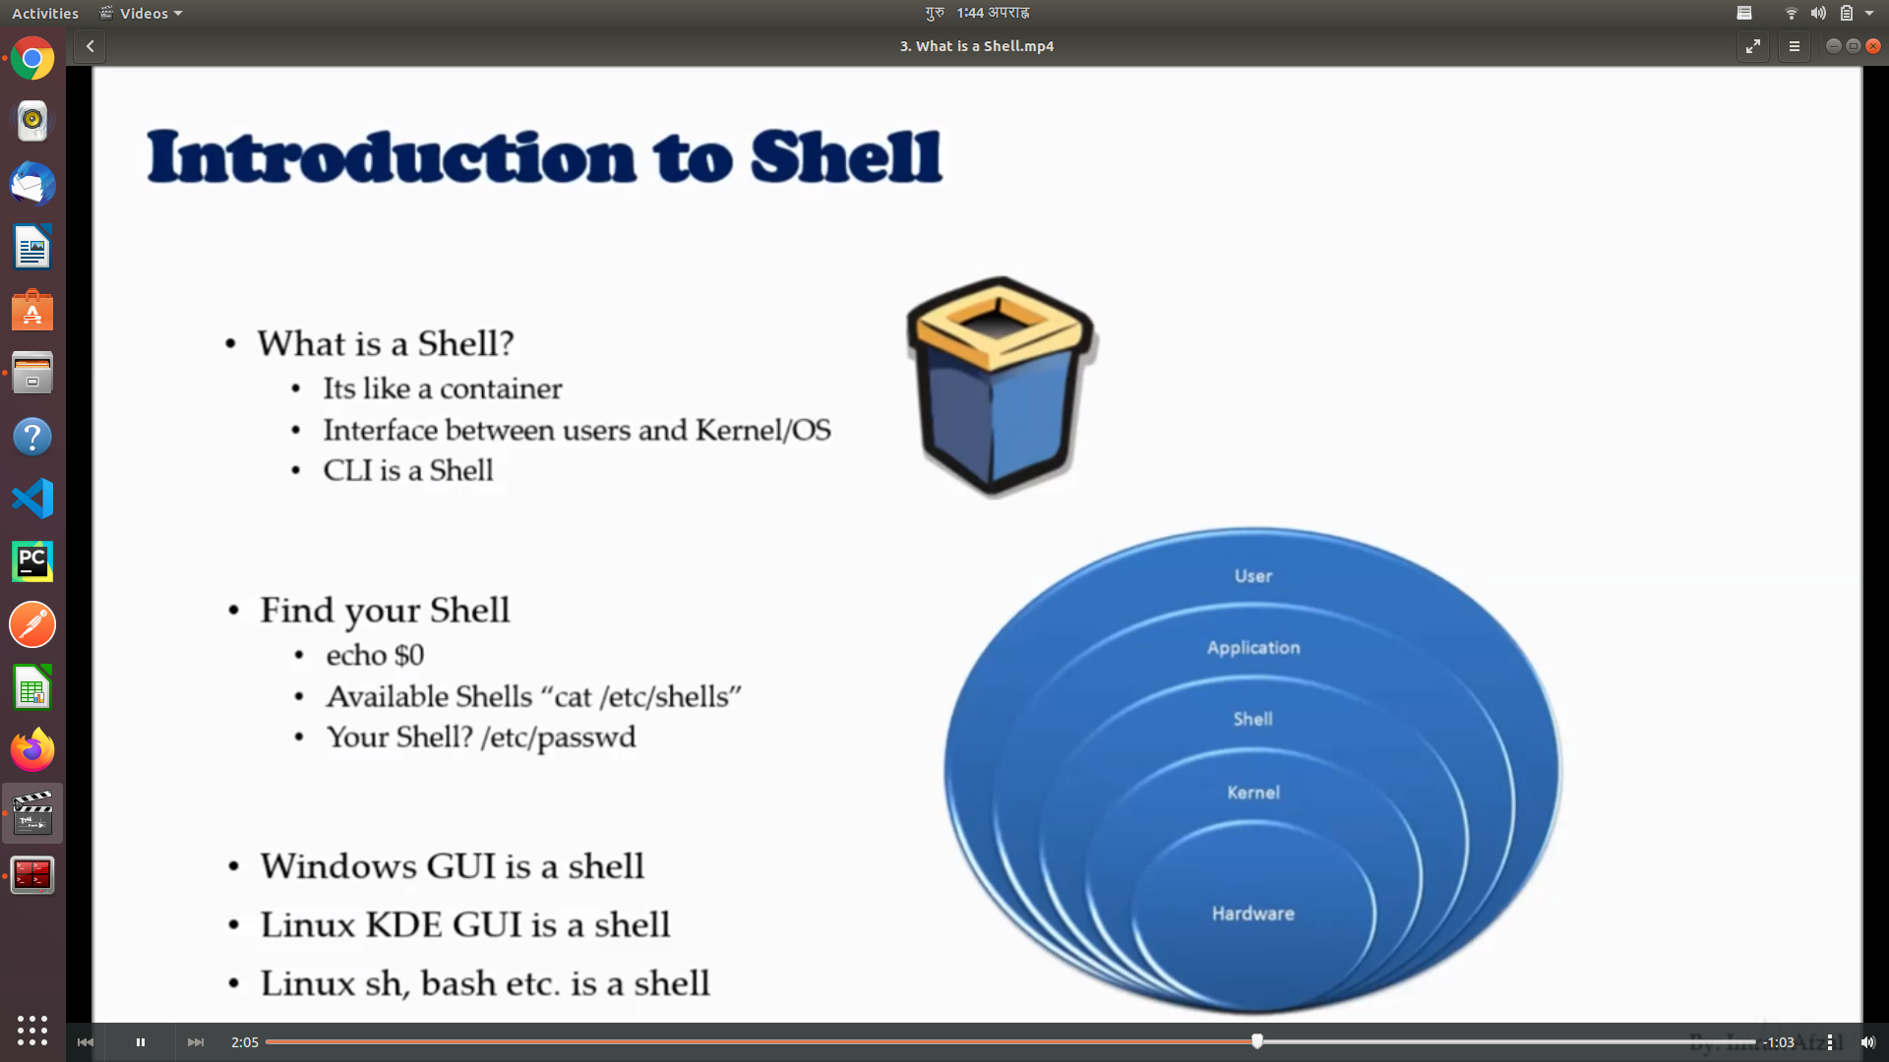

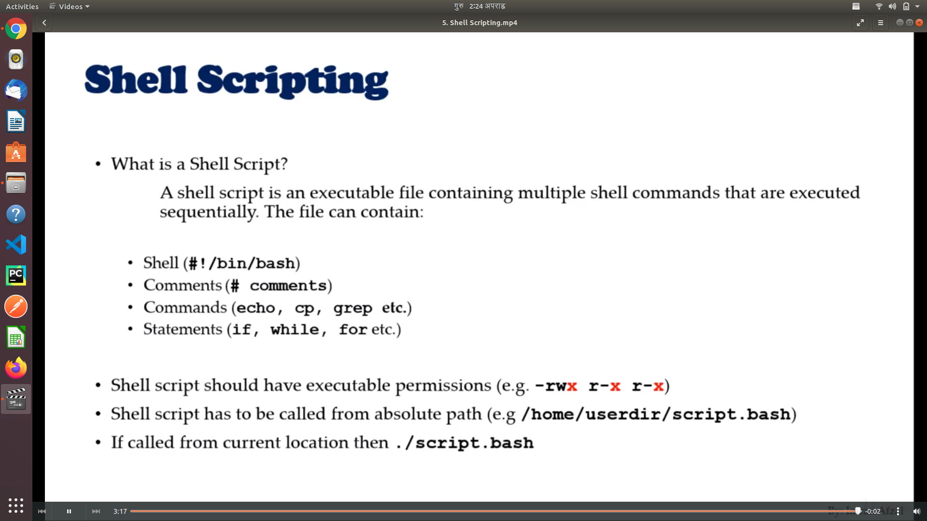

**History Command**

history

Gives shell history

1984 cdat d0_while_loop.sh

1985 cat d0_while_loop.sh

1986 clear

1987 ls

1988 cat case_statement.sh

1989 alias

1990 history

You can run command from shell history as

$ !1989

The file where you shell history saved is :

/home/sandip/.bash_history

**Network File And Commands**

* Interface Detection
* Assigning an IP address
* Interface configuration files
  + **/etc/nsswitch.conf**
  + **/etc/hostname**
  + **/etc/sysconfig/network**
  + **/etc/sysconfig/network-scripts/ifcfg-nic**
  + **/etc/resolv.conf**
* **Network commands**

1. **ping**
2. **ifconfig**
3. **Ifup or ifdown**

**ifup <interface_name>**

1. **netstat**

**netstat -rnv**

1. **tcpdump**

**tcpdump -i <interface_name>**

**wget <url_to_the_file_or_application_to_download>**

**Curl And Ping Command**

**File Transfer Commands**

* **ftp (file transfer protocal)**

## **The ftp Command**

Assuming you have a valid account on an FTP site, you can connect to it with the following command. Throughout this article, substitute the IP address in the commands with the IP address of the FTP server you’re connecting to.

ftp 192.168.4.25

Warning: You should only use the ftp command to connect to servers on a trusted local network. Use the sftp command, covered below, for transferring files over the internet.

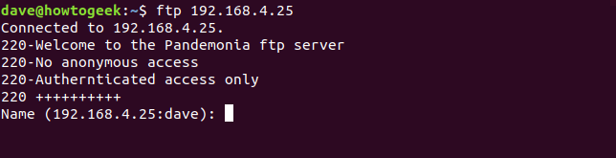

The FTP server responds with a welcome message. The wording of the greeting will vary from server to server. It then asks for the username of the account you are logging into.

Notice that the IP address of the site you’re connecting to is displayed, followed by your Linux user name. If your account name on the FTP server is the same as your Linux user name, simply press the Enter key. This will use your Linux user name as the account name on the FTP server. If your Linux user name and the FTP account name are different, type in the FTP account user name and then press Enter.

## **Logging In to the FTP Server**

You will be prompted to enter your password for the FTP site. Enter your password and press Enter. Your password is not displayed on the screen. If your FTP user account name and password combination are verified by the FTP server, you are then logged into the FTP server.

You will be presented with the ftp> prompt.

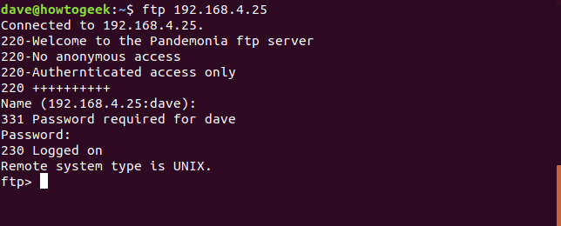

## **Looking Around and Retrieving Files**

First, you’ll probably want to get a listing of the files on the FTP server. The ls command does just that. Our user sees the file gc.c is on the FTP server, and he wants to download it to his own computer. His computer is the “local computer” in FTP parlance.

The command to retrieve (or “get”) a file is get. Our user, therefore, issues the command get gc.c. They type get, a space, and then the name of the file they wish to retrieve.

The FTP server responds by transferring the file to the local computer and confirming the transfer took place. The size of the file and the time it took to transfer are also shown.

ls

get gc.c

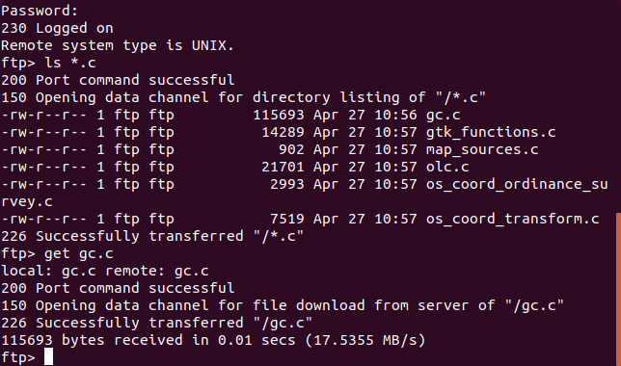

To retrieve multiple files at once, use the mget (multiple get) command. The mget command will ask you to confirm whether you want to download each file in turn. Respond by pressing “y” for yes and “n” for no.

This would be tedious for a great number of files. Because of this, collections of related files are usually stored on ftp sites as single [tar.gz or tar.bz2 files](https://www.howtogeek.com/409742/how-to-extract-files-from-a-.tar.gz-or-.tar.bz2-file-on-linux/).

RELATED: [*How to Extract Files From a .tar.gz or .tar.bz2 File on Linux*](https://www.howtogeek.com/409742/how-to-extract-files-from-a-.tar.gz-or-.tar.bz2-file-on-linux/)

mget *.c

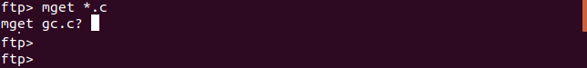

## **Uploading Files to the FTP Server**

Depending on the permissions that have been granted to your FTP account you might be able to upload (or “put”) files to the server. To upload a file, use the put command. In our example, the user is uploading a file called Songs.tar.gz to the FTP server.

put Songs.tar.gz

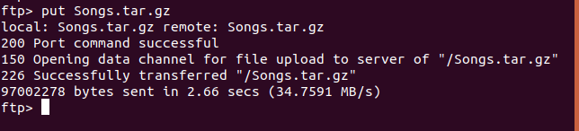

As you probably expect, there is a command to put multiple files to the FTP server at once. It is called mput (multiple put). Just like the mget command did, mput will ask for a “y” or “n” confirmation for the uploading of each file, one by one.

The same argument for putting sets of files into tar archives applies for putting files as it does for getting files. Our user is uploading multiple “.odt” files with the following command:

mput *.odt

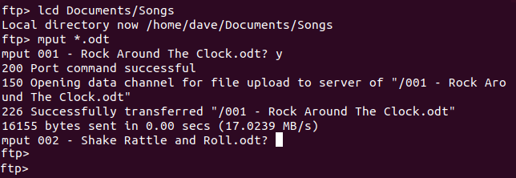

## **Creating and Changing Directories**

If your user account on the ftp server permits it, you may be able to create directories. The command to do this is mkdir . To be clear, any directory you create with the mkdir command will be created on the ftp server and not on your local computer.

To change directories on the ftp server, use the cd command. When you use the cd command the ftp> prompt will not change to reflect your new current directory. The pwd (print working directory) command will show you your current directory.

Our ftp user creates a directory called music, changes into that new directory, confirms where they are by using the pwd command then uploads a file to that directory.

mkdir music

cd music

pwd

put songs.tar.gz

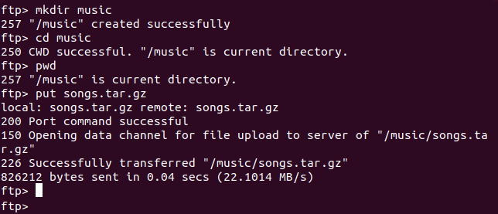

To quickly moved to the parent directory of the current directory use the cdup command.

cdup

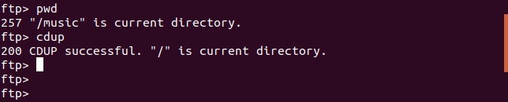

## **Accessing the Local Computer**

To change the directory on the local computer, you can use the lcd command at the ftp> prompt. It is, however, easy to lose track of where you are in the local filesystem. A more convenient method of accessing the local filesystem is to use the ! command.

The ! command opens a shell window to the local computer. You can do anything in this shell that you can in a standard terminal window. When you type exit you are returned to the ftp> prompt.

Our user has used the ! command and entered a shell window on the local computer. They have issued an ls command to see what files are present in that directory and then typed exit to return to the ftp> prompt.

!

ls

exit

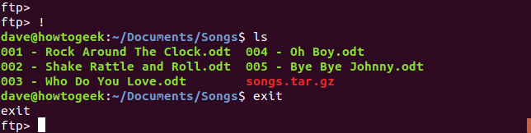

## **Renaming Files**

To rename files on the FTP server use the rename command. Here our FTP user renames a file with rename and then uses the ls command to list the files in the directory.

rename songs.tar.gz rock_songs.tar.gz

ls

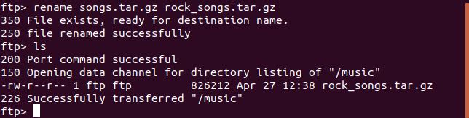

## **Deleting Files**

To delete files on the FTP server use the delete command. To delete several files at once, use the mdelete command. You will be asked to provide a “y” or “n” confirmation for the deletion of each file.

Here our FTP user has listed the files to see their names and then chosen one to delete. They then decide to delete them all.

ls

delete gc.o

mdelete *.o

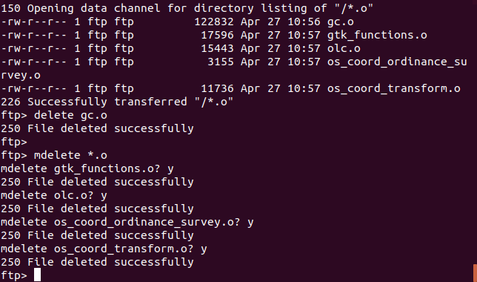

## **Using the sftp Command**

Readers familiar with the IP addressing system will have noticed that the 192.168 address of the FTP server used in the above examples is an internal IP address, also called a private IP address. As we warned at the beginning of this article, the ftp command should only be used on internal networks.

If you want to connect to a remote or public FTP server use the sftp command. Our user is going to connect to an SFTP account called demo on the publicly accessible FTP server located at test.trebex.net.

When they connect, they are informed that the connection has been established. They are also informed that the authenticity of the host cannot be verified. This is normal for the first connection a new host. They press “y” to accept the connection.

Because the user account name (demo) was passed on the command line they are not prompted for the user account name. They are prompted only for the password. This is entered, verified and accepted, and they are presented with the sftp> prompt.

sftp demo@test.rebex.net

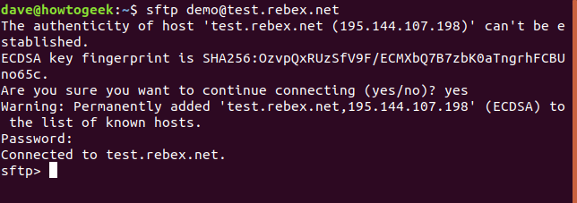

The FTP commands we have described above will work just the same in an SFTP session, with the following exceptions.

* To delete a file use rm (FTP uses delete)
* To delete multiple files use rm (FTP uses mdelete)
* To move to the parent directory use cd .. (FTP uses cdup)

Our user has used a few commands in their SFTP session. They have use ls to list the files, and cd to change into the pub directory. They have used the pwd to print the working directory.

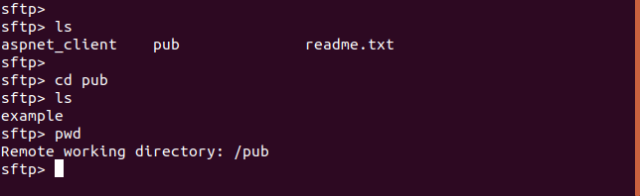

There are other options to transfer files in the Linux world, notably scp ([secure copy](https://linux.die.net/man/1/scp)), but we’ve focused on FTP and SFTP here. Used in the applicable scenarios these two commands will serve you and your file storage and retrieval needs well.

* **scp (secure copy protocal)**

SCP (secure copy) is a command-line utility that allows you to securely copy files and directories between two locations.

With scp, you can copy a file or directory:

* From your local system to a remote system.
* From a remote system to your local system.
* Between two remote systems from your local system.

When transferring data with scp, both the files and password are encrypted so that anyone snooping on the traffic doesn’t get anything sensitive.

In this tutorial, we will show you how to use the scp command through practical examples and detailed explanations of the most common scp options.

## **SCP Command Syntax**

Before going into how to use the scp command, let’s start by reviewing the basic syntax.

The scp command syntax take the following form:

scp [OPTION] [user@]SRC_HOST:]file1 [user@]DEST_HOST:]file2

Copy

* OPTION - [scp options](https://linux.die.net/man/1/scp) such as cipher, ssh configuration, ssh port, limit, recursive copy …etc.
* [user@]SRC_HOST:]file1 - Source file.
* [user@]DEST_HOST:]file2 - Destination file

Local files should be specified using an absolute or relative path, while remote file names should include a user and host specification.

scp provides a number of options that control every aspect of its behavior. The most widely used options are:

* -P - Specifies the remote host ssh port.
* -p - Preserves files modification and access times.
* -q - Use this option if you want to suppress the progress meter and non-error messages.
* -C - This option forces scp to compresses the data as it is sent to the destination machine.
* -r - This option tells scp to copy directories recursively.

## **Before you Begin**

The scp command relies on ssh for data transfer, so it requires an ssh key or password to authenticate on the remote systems.

The colon (:) is how scp distinguish between local and remote locations.

To be able to copy files, you must have at least read permissions on the source file and write permission on the target system.

Be careful when copying files that share the same name and location on both systems, scp will overwrite files without warning.

When transferring large files, it is recommended to run the scp command inside a [screen](https://linuxize.com/post/how-to-use-linux-screen/) or [tmux](https://linuxize.com/post/getting-started-with-tmux/) session.

## **Copy Files and Directories Between Two Systems with scp**

### **Copy a Local File to a Remote System with the scp Command**

To copy a file from a local to a remote system run the following command:

scp file.txt remote_username@10.10.0.2:/remote/directory

Where file.txt is the name of the file we want to copy, remote_username is the user on the remote server, 10.10.0.2 is the server IP address. The /remote/directory is the path to the directory you want to copy the file to. If you don’t specify a remote directory, the file will be copied to the remote user home directory.

You will be prompted to enter the user password, and the transfer process will start.

remote_username@10.10.0.2's password:

file.txt 100% 0 0.0KB/s 00:00

Omitting the filename from the destination location copies the file with the original name. If you want to save the file under a different name, you need to specify the new file name:

scp file.txt remote_username@10.10.0.2:/remote/directory/newfilename.txt

If SSH on the remote host is listening on a port other than the default 22 then you can specify the port using the -P argument:

scp -P 2322 file.txt remote_username@10.10.0.2:/remote/directory

The command to copy a directory is much like as when copying files. The only difference is that you need to use the -r flag for recursive.

To copy a directory from a local to remote system, use the -r option:

scp -r /local/directory remote_username@10.10.0.2:/remote/directory

### **Copy a Remote File to a Local System using the scp Command**

To copy a file from a remote to a local system, use the remote location as a source and local location as the destination.

For example to copy a file named file.txt from a remote server with IP 10.10.0.2 run the following command:

scp remote_username@10.10.0.2:/remote/file.txt /local/directory

If you haven’t set a [passwordless SSH login](https://linuxize.com/post/how-to-setup-passwordless-ssh-login/) to the remote machine, you will be asked to enter the user password.

### **Copy a File Between Two Remote Systems using the scp Command**

Unlike [rsync](https://linuxize.com/post/how-to-use-rsync-for-local-and-remote-data-transfer-and-synchronization/), when using scp you don’t have to log in to one of the servers to transfer files from one to another remote machine.

The following command will copy the file /files/file.txt from the remote host host1.com to the directory /files on the remote host host2.com.

scp user1@host1.com:/files/file.txt user2@host2.com:/files

You will be prompted to enter the passwords for both remote accounts. The data will be transfer directly from one remote host to the other.

To route the traffic through the machine on which the command is issued, use the -3 option:

scp -3 user1@host1.com:/files/file.txt user2@host2.com:/files

* **rsync**

Rsync is a fast and versatile command line utility that synchronizes files and folders between two locations over a remote shell, or from/to a remote Rsync daemon. It provides fast incremental file transfer by transferring only the differences between the source and the destination.

Rsync can be used for mirroring data, incremental backups, copying files between systems and as a replacement for [scp](https://linuxize.com/post/how-to-use-scp-command-to-securely-transfer-files/), [sftp](https://linuxize.com/post/how-to-use-linux-sftp-command-to-transfer-files/), and [cp](https://linuxize.com/post/cp-command-in-linux/) commands for everyday use.

In this tutorial, we will show you how to use rsync through practical examples and detailed explanations of the most common rsync options.

## **Installing Rsync**

The rsync utility is pre-installed on most Linux distributions and macOS. You can check if it is installed on your system by typing:

rsync --version

rsync version 3.1.2 protocol version 31

If you don’t have rsync installed on your system, you can easily install it using your distribution’s package manager.

### **Install Rsync on Ubuntu and Debian**

sudo apt install rsync

### **Install Rsync on CentOS and Fedora**

sudo yum install rsync

## **Rsync Command Syntax**

Before going into how to use the rsync command, let’s start by reviewing the basic syntax.

The rsync utility expressions take the following form:

Local to Local: rsync [OPTION]... [SRC]... DEST

Local to Remote: rsync [OPTION]... [SRC]... [USER@]HOST:DEST

Remote to Local: rsync [OPTION]... [USER@]HOST:SRC... [DEST]

Copy

* OPTION - The [rsync options](https://linux.die.net/man/1/rsync).
* SRC - Source directory.
* DEST - Destination directory.
* USER - Remote username.
* HOST - Remote hostname ot IP Address.

rsync provides a number of options that control every aspect of its behavior. The most widely used options are:

* -a, --archive, archive mode, equivalent to -rlptgoD. This option tells rsync to syncs directories recursively, transfer special and block devices, preserve symbolic links, modification times, group, ownership, and permissions.
* -z, --compress. This option will force rsync to compresses the data as it is sent to the destination machine. Use this option only if the connection to the remote machine is slow.
* -P, equivalent to --partial --progress. When this option is used rsync will show a progress bar during transfer and to keep the partially transferred files. It is useful when transferring large files over slow or unstable network connections.
* --delete. When using this option rsync will delete extraneous files from the destination location. It is useful for mirroring.
* -q, --quiet. Use this option if you want to suppress non-error messages.
* -e. This option allows you to choose a different remote shell. By default, rsync is configured to use ssh.

## **Basic Rsync Usage**

To copy a single file from one to another local location you would run the following command:

rsync -a /opt/filename.zip /tmp/



The user running the command must have read permissions on the destination location and write permissions on the destination.

Omitting the filename from the destination location copies the file with the current name. If you want to save the file under a different name, specify the new name on the destination part:

rsync -a /opt/filename.zip /tmp/newfilename.zip

In the example below we are creating a local backup of our website files:

rsync -a /var/www/domain.com/public_html/ /var/www/domain.com/public_html_backup/

If the destination directory doesn’t exist rsync will create it.

It is worth mentioning that rsync gives different treatment to the source directories with a trailing slash /. If you add a trailing slash on the source directory it will copy only the contents of the directory to the destination directory. When the trailing slash is omitted rsync will copy the source directory inside the destination directory.

## **How To Use Rsync to Sync Data from/to a remote Machine**

When using rsync for [remote transfer](https://linuxize.com/post/how-to-transfer-files-with-rsync-over-ssh/), it must be installed on both the source and the destination machine. The new versions of rsync are configured to use SSH as default remote shell.

In the following example, we are transferring a directory from a local to a remote machine:

rsync -a /opt/media/ remote_user@remote_host_or_ip:/opt/media/

If you haven’t set a [passwordless SSH login](https://linuxize.com/post/how-to-setup-passwordless-ssh-login/) to the remote machine, you will be asked to enter the user password.

If you want to transfer data from a remote to a local machine then you need to use the remote location as a source:

rsync -a remote_user@remote_host_or_ip:/opt/media/ /opt/media/

If SSH on the remote host is listening on a port other than the default 22 then you can specify the port using the -e option:

rsync -a -e "ssh -p 2322" /opt/media/ remote_user@remote_host_or_ip:/opt/media/

When transferring large amounts of data it is recommended to run the rsync command inside a [screen](https://linuxize.com/post/how-to-use-linux-screen/) session or use the -P option:

rsync -a -P remote_user@remote_host_or_ip:/opt/media/ /opt/media/

## **Exclude Files and Directories**

When [excluding files or directories](https://linuxize.com/post/how-to-exclude-files-and-directories-with-rsync/) you need to use their relative paths to the source location.

There are two options to exclude files and directories. The first option is to use the --exclude argument and specify the files and directories you want to exclude on the command line.

In the following example, we are excluding the node_modules and tmp directories which are located inside the src_directory:

rsync -a --exclude=node_modules --exclude=tmp /src_directory/ /dst_directory/

The second option is to use the --exclude-from argument and specify the files and directories you want to exclude in a file.

rsync -a --exclude-from='/exclude-file.txt' /src_directory/ /dst_directory/

**Advance package management**

* Installing packages

**sudo apt install ksh\***

**\* means related to korn shell dependency will also be downloaded**

When you use apt to install a package, [under the hood](https://wiki.debian.org/DebianPackageManagement) it uses dpkg. When you install a package using apt, it first creates a list of all the dependencies and downloads it from the repository.

Once the download is finished it calls dpkg to install all those files, satisfying all the dependencies.

### So if you have a .deb file, you can install it by:

1. Using:  
   sudo dpkg -i /path/to/deb/file

sudo apt-get install -f

1. Using:  
   sudo apt install ./name.deb  
    Or  
   sudo apt install /path/to/package/name.deb  
    With old apt-get versions you must first move your deb file to /var/cache/apt/archives/ directory. For both, after executing this command, it will automatically download its dependencies.
2. First installing gdebi and then opening your .deb file using it (*Right-click* -> *Open with*). It will install your .deb package with all its dependencies.  
   **Note**: APT maintains the package index which is a database of available packages available in repo defined in /etc/apt/sources.list file and in the /etc/apt/sources.list.d directory. All these methods will fail to satisfy the software dependency if the dependencies required by the deb is not present in the package index.

### Why use sudo apt-get install -f after sudo dpkg -i /path/to/deb/file (as mentioned in method 1)?

From man apt-get:

-f, --fix-broken Fix; attempt to correct a system with broken dependencies in place.

When dpkg installs a package and a package dependency is not satisfied, it leaves the package in an "unconfigured" state and that package is considered broken.

The sudo apt-get install -f command tries to fix this broken package by installing the missing dependency.

* Upgrading
* Deleting
* View Package Detail Information
* Identify Source Or Location Information

dpkg -S $(which ls)

Find which package command belongs to

* Packages configuration files

dpkg command for package management

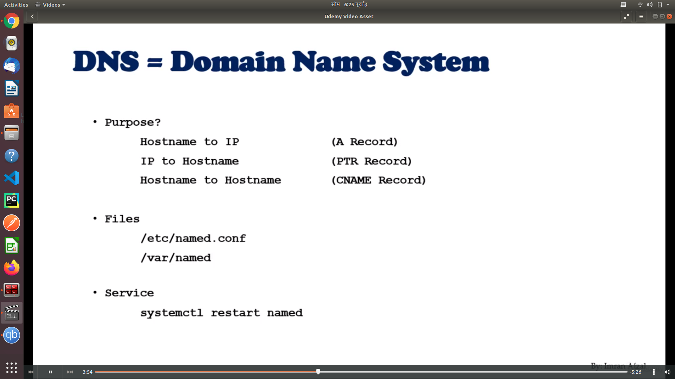

**Hostname or IP Lookup**

Commands used for DNS lookup:

* nslookup
* dig
* host

### **Nslookup**

Nslookup is widely used to resolve the hostname to an IP address. In order to use this command for an IP lookup, use the following syntax:

*$* nslookup target-host

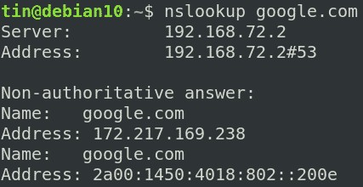

### **Host**

Another command-line utility “host” can be used to find IP address against any hostname/domain name. In order to use this command, use the following syntax:

*$* host target-host

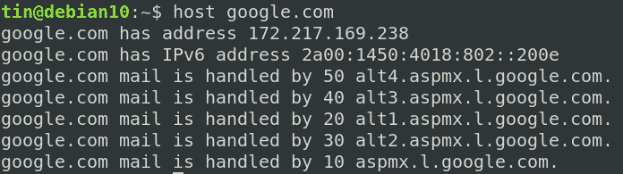

### **Dig**

Dig is another useful command line tool that is used to query various DNS related records. It can be used to find IP address against any hostname/domain name. Use Dig command in the following way to find an IP address against a specific hostname/domain name.

*$* dig target-host +short

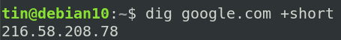

**NTP (Network Time Protocol)**

The NTP system is based on Internet *time servers*, computers with access to atomic clocks such as those operated by the U.S. government. These NTP servers run a software service that provides the clock's time of day to client computers over [UDP](http://compnetworking.about.com/library/glossary/bldef-udp.htm) port 123. NTP supports a hierarchy of multiple server levels to handle a large load of client requests. The protocol includes algorithms to accurately adjust the time of day being reported to account for Internet network transmission delays.

Computers running Windows, Mac OS X and Linux operating systems can be configured to use an NTP server. Starting with Windows XP, for example, the Control Panel "Date and Time" option contains an Internet Time tab which allows choosing an NTP server and turning time synchronization on or off

The process name of the service = ntpd

Name of the rpm = ntpd

* First check to see if you OS has already service rpm package installed on the system

rpm -qa | grep ntp

ntp.x.x.x.x86_64

ntpdate.x.x.x86_64

* If the above rpms exist then you can proceed with the configuration
* If the rpms do not exist then download the package/rpm using yum command

yum install ntpd -y

* Once the package is installed make changes to the following configuration file:

/etc/ntp.conf (Linux)

Add NTP server IP or hostname where server parameters are defined

server ntp-hostname

* Now start the service

systemctl restart ntpd

* Also in order to have the service startup at the boot time run the following command

systemctl enable ntpd

* NTP Logs location

/var/log/messages

* **Commands**

ps -ef | grep ntp

OR

ntpq peers quit

ntpdate = Set date and time via ntp

ntpdate –v hostname = To manually force the time to sync with ntp server

* **List of NTP Servers on Web:**

<http://www.pool.ntp.org/zone/north-america>

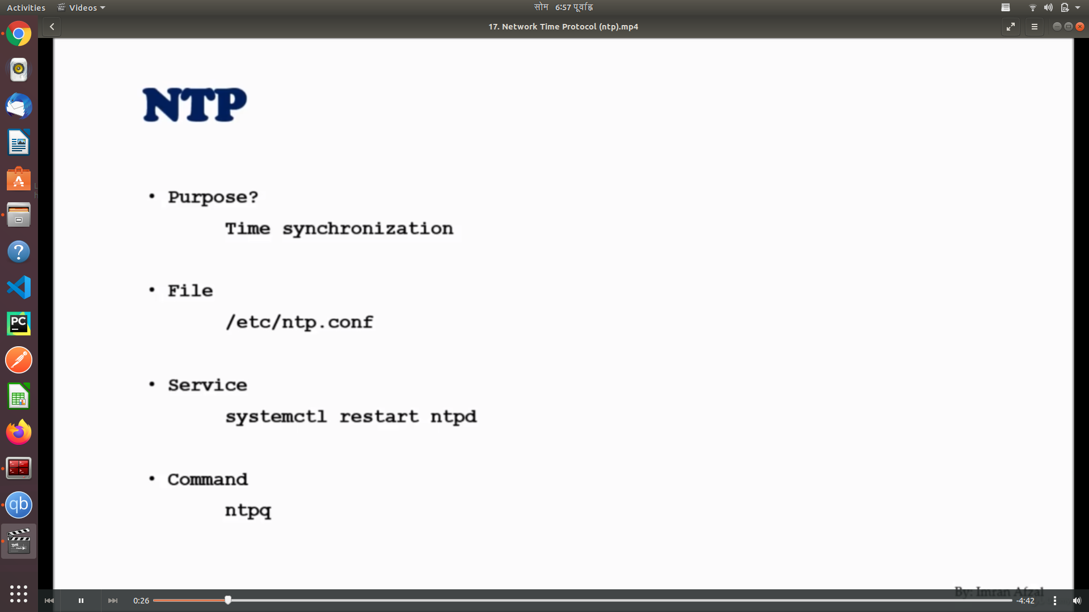

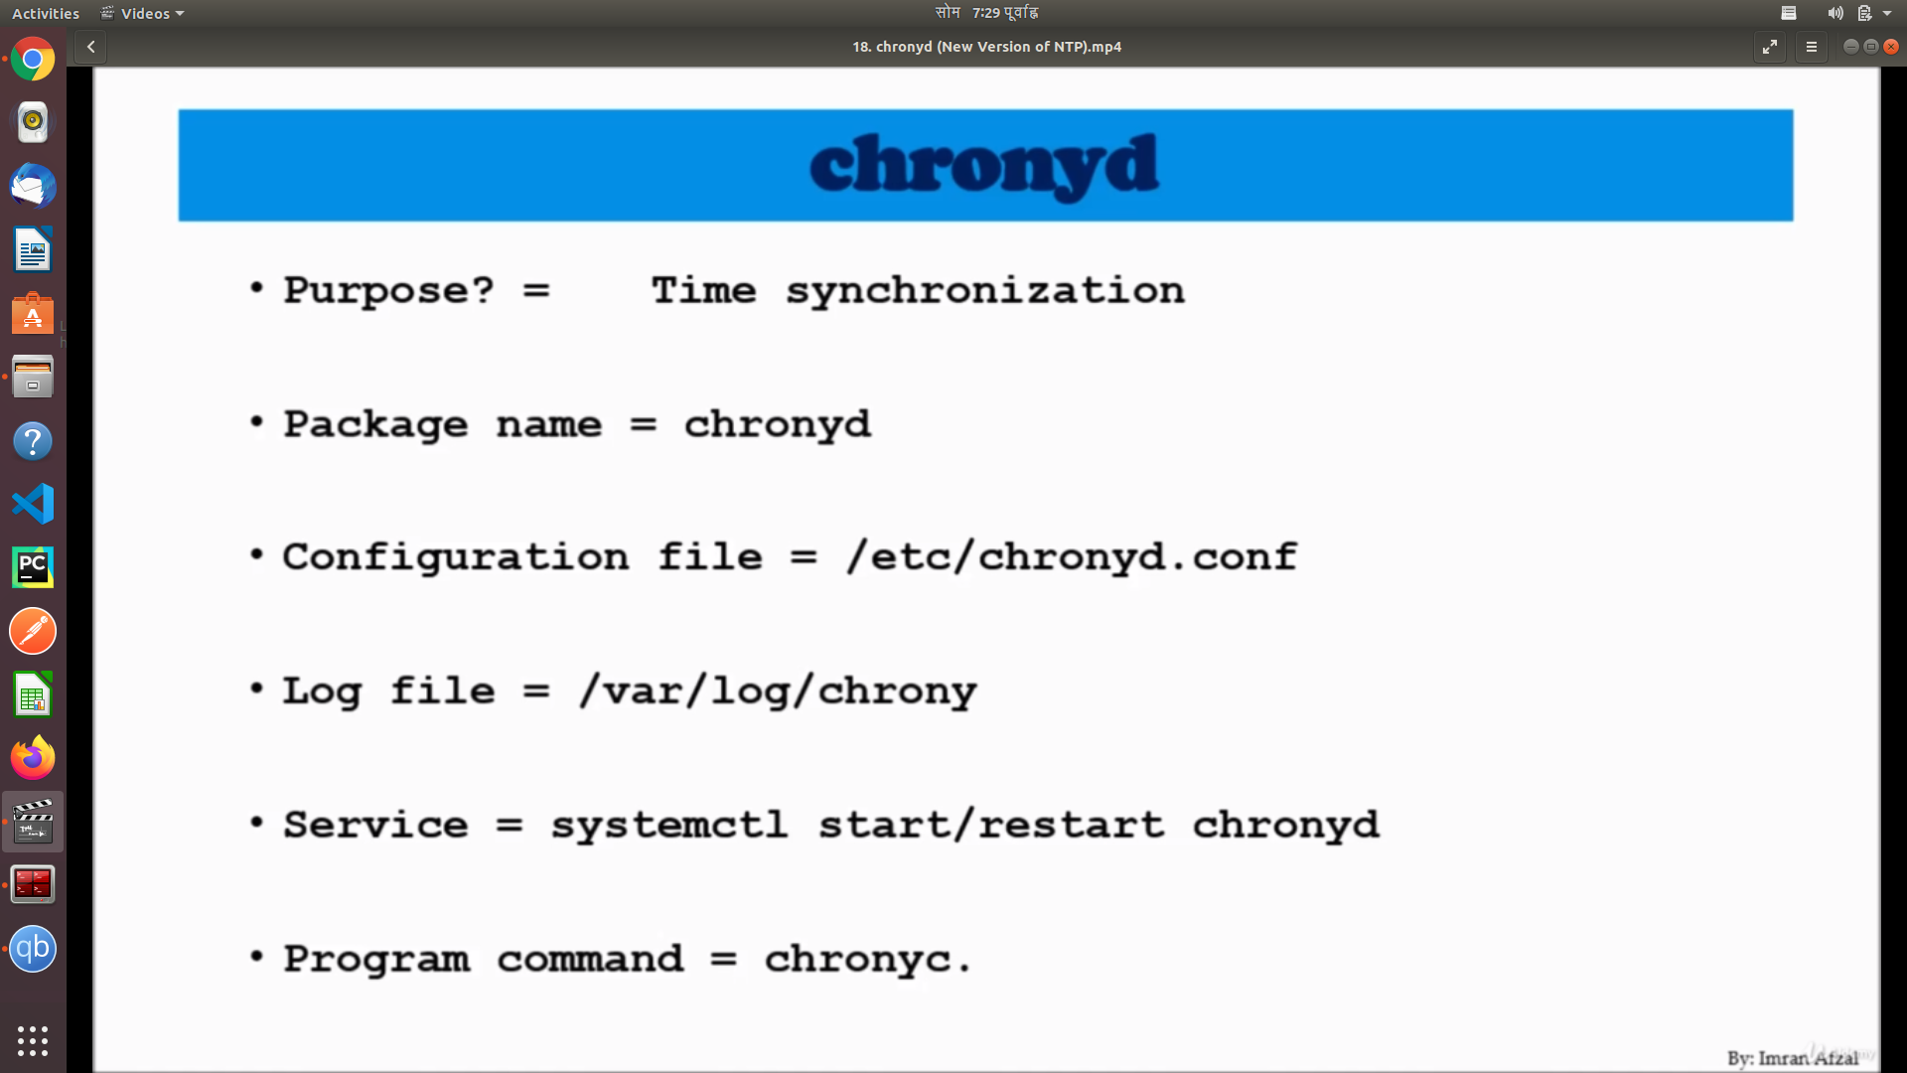

**Chrony is new version**

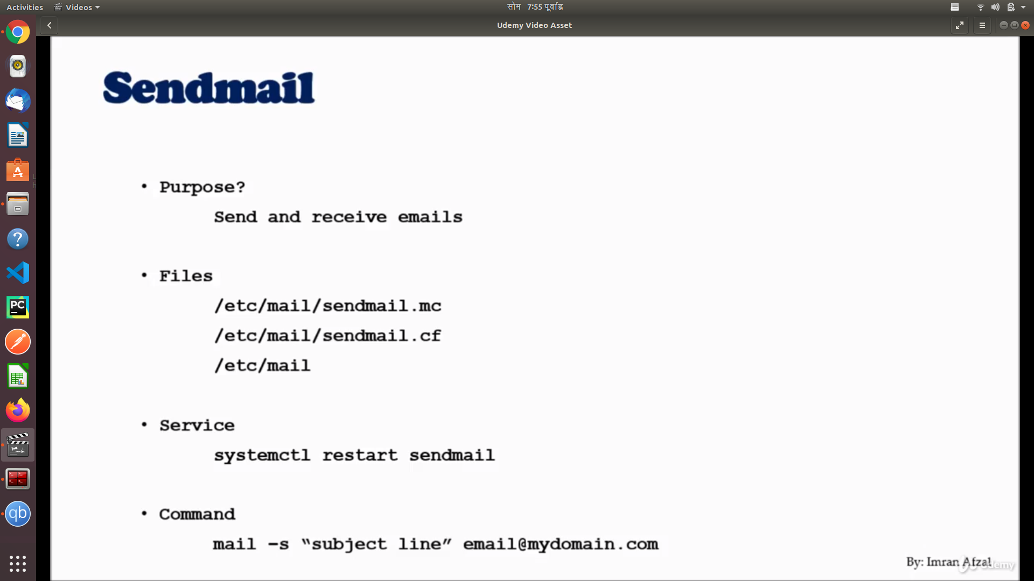

**Central Logger(rsyslog)**

**chage -l <user_name>**

**(**shows password information for username**)**

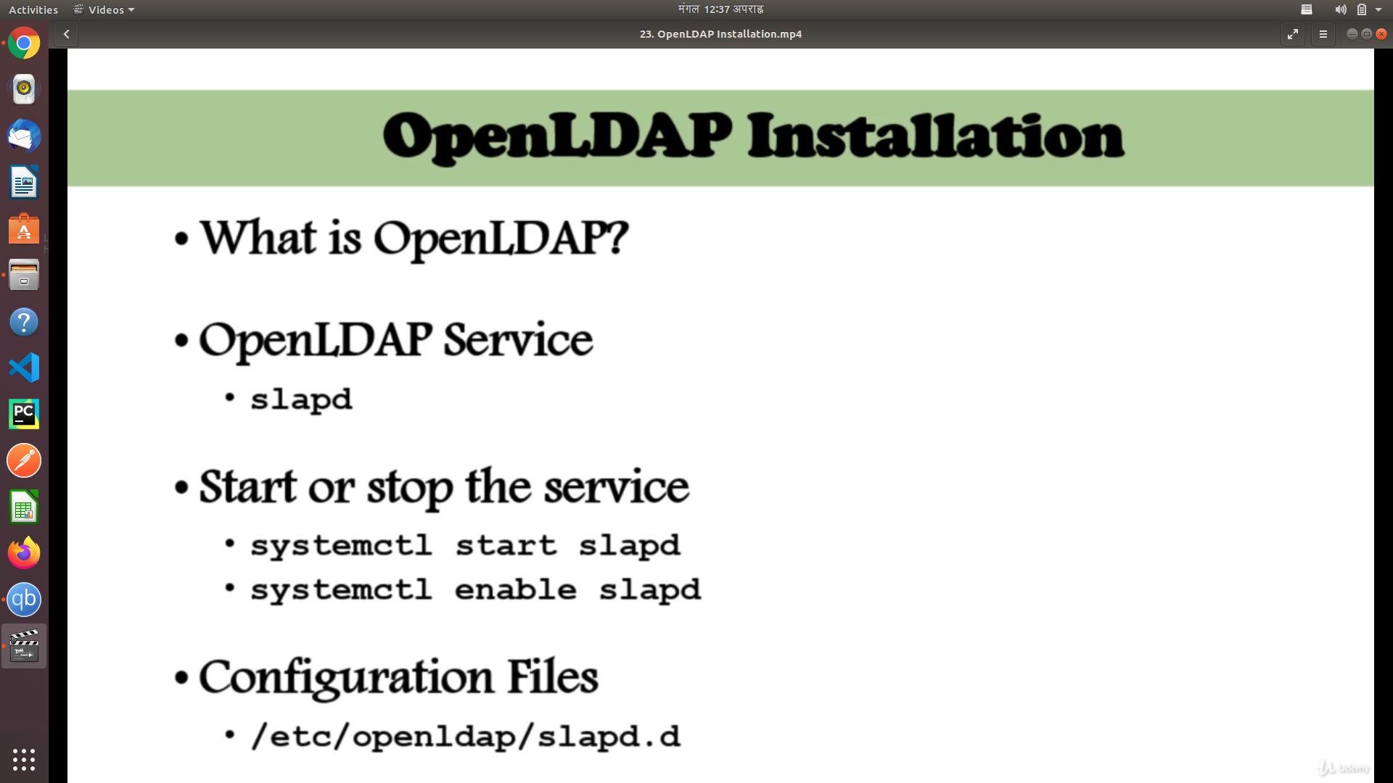

**Web server (httpd)**

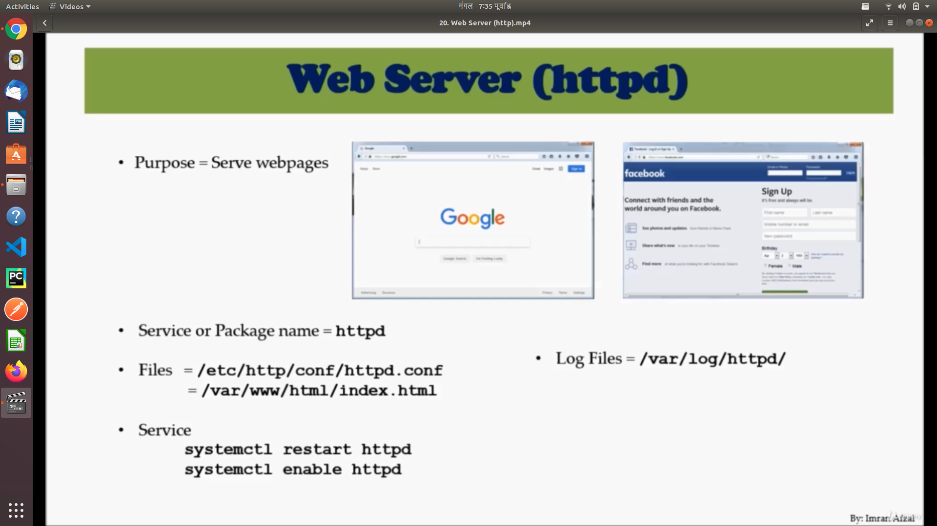

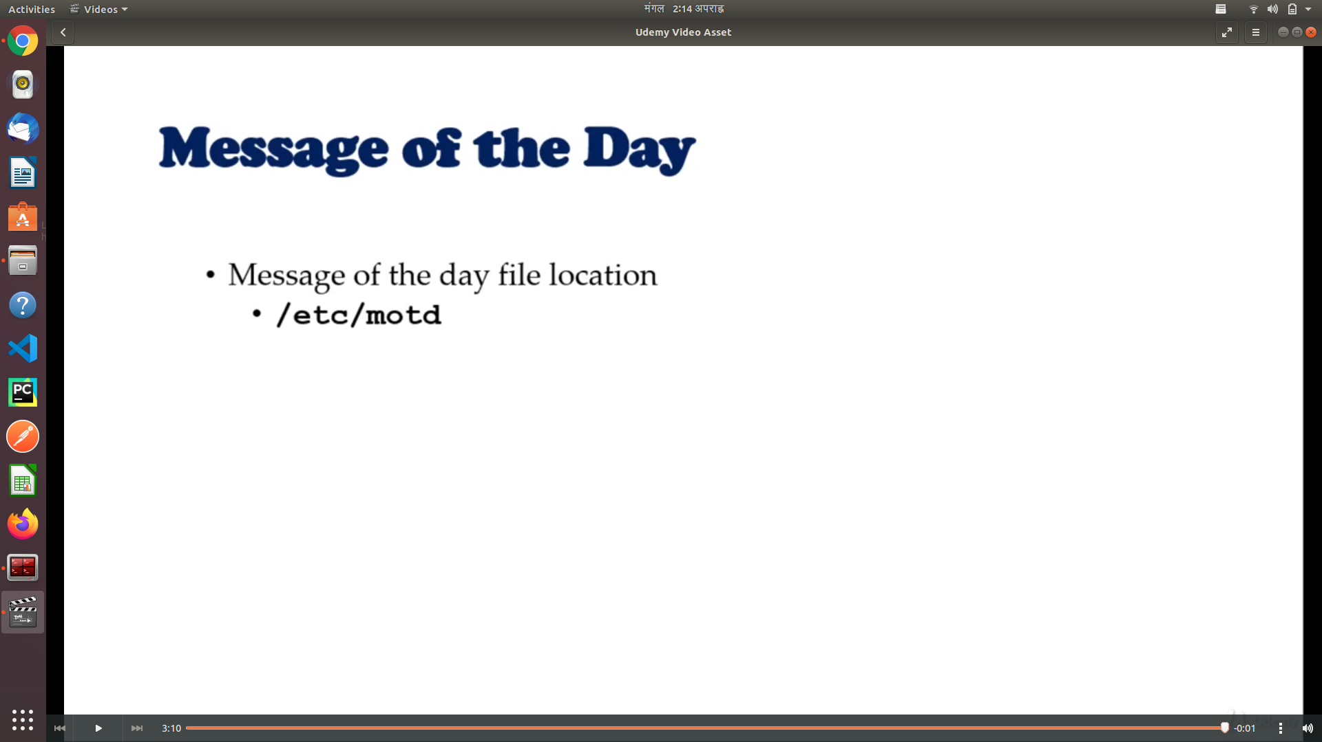

**Disk partition**

* **df**
* **fdisk**

**Adding Disk and Creating Partition**

* **Add a disk**
* **fdisk -l (find the disk you added)**
* **fisk /dev/<t0_disk>**
* **It will open command**
* **Type help**
* **Create the partition using commands**
* **Then choose file system**
* **mkfs.xfs /dev/sdv1(your volume)**
* **Now mount the disk**
* **mkdir /<directory_name>**
* **Mount directory to partition**
* **mount /dev/<to_disk_partiton> /<directory name>**
* **df -h (you can see the partiton)**
* **Every time you reboot it will not be mounted you need to make a entry to /etc/fstab**
* **Go to the bottom of file /etc/fstab add a new line**

**/dev/<to_partition_name> /mounted_<directory> ..**

**<file_system_type> defaults 0 0**

**As system administrators, we would have got requirements wherein we need to configure raw hard disks to the existing servers as part of upgrading server capacity or sometimes disk replacement in case of disk failure.**

**In this article, I will take you through the steps by which we can add the new raw hard disk to an existing Linux server such as RHEL/CentOS or Debian/Ubuntu.**

**Suggested Read:** [**How to Add a New Disk Larger Than 2TB to An Existing Linux**](https://www.tecmint.com/add-disk-larger-than-2tb-to-an-existing-linux/)

**Important: Please note that the purpose of this article is to show only how to create a new partition and doesn’t include partition extension or any other switches.**

**I am using** [**fdisk utility**](https://www.tecmint.com/fdisk-commands-to-manage-linux-disk-partitions/) **to do this configuration.**

**I have added a hard disk of 20GB capacity to be mounted as a** /data **partition.**

**fdisk is a command line utility to view and manage hard disks and partitions on Linux systems.**

**# fdisk -l**

**This will list the current partitions and configurations.**

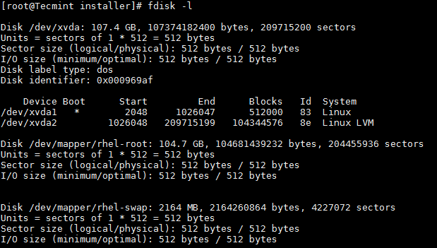

***Find Linux Partition Details***

**After attaching the hard disk of 20GB capacity, the** fdisk -l **will give the below output.**

**# fdisk -l**

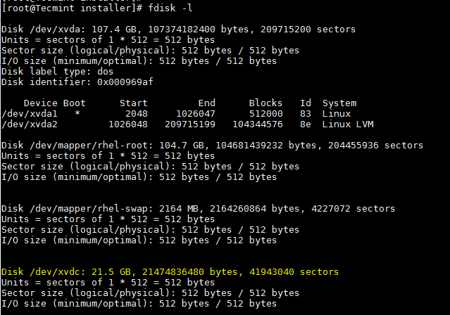

***Find New Partition Details***

**New disk added is shown as** /dev/xvdc**. If we are adding physical disk it will show as** /dev/sda **based of the disk type. Here I used a virtual disk.**

**To partition a particular hard disk, for example /dev/xvdc.**

**# fdisk /dev/xvdc**

**Commonly used fdisk commands.**

* n **– Create partition**
* p **– print partition table**
* d **– delete a partition**
* q **– exit without saving the changes**
* w **– write the changes and exit.**

**Here since we are creating a partition use** n **option.**

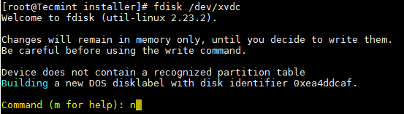

***Create New Partition in Linux***

**Create either primary/extended partitions. By default we can have upto 4 primary partitions.**

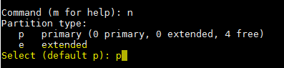

***Create Primary Partition***

**Give the partition number as desired. Recommended to go for the default value** 1**.**



***Assign a Partition Number***

**Give the value of the first sector. If it is a new disk, always select default value. If you are creating a second partition on the same disk, we need to add** 1 **to the last sector of the previous partition.**



***Assign Sector to Partition***

**Give the value of the last sector or the partition size. Always recommended to give the size of the partition. Always prefix** + **to avoid value out of range error.**



***Assign Partition Size***

**Save the changes and exit.**

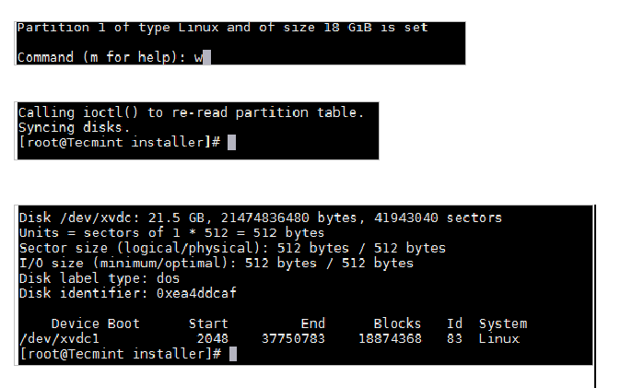

***Save Partition Changes***

**Now format the disk with mkfs command.**

**# mkfs.ext4 /dev/xvdc1**

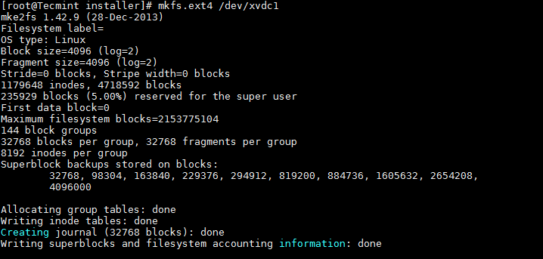

***Format New Partition***

**Once formatting has been completed, now mount the partition as shown below.**

**# mount /dev/xvdc1 /data**

**Make an entry in /etc/fstab file for permanent mount at boot time.**

**/dev/xvdc1 /data ext4 defaults 0 0**

**Logical Volume Management**

